

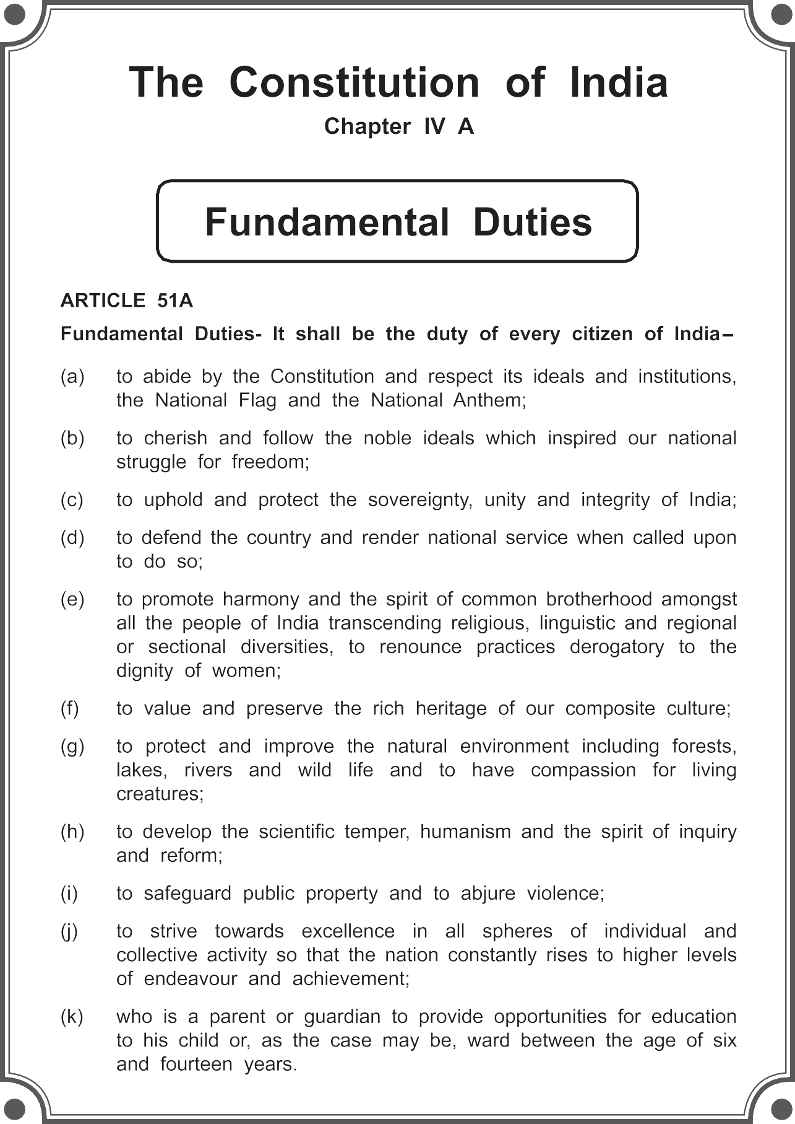

The Coordination Committee formed by GR No. Abhyas - 2116/(Pra.Kra.43/16) SD - 4 Dated 25.4.2016 has given approval to prescribe this textbook in its meeting held on 3.3.2017

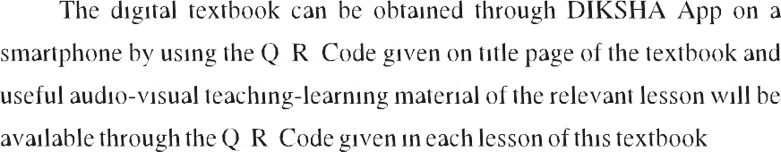

**ENGLISH**

**BALBHARATI**

**STANDARD SEVEN**

**Maharashtra State Bureau of Textbook Production and Curriculum Research, Pune.**

**First Edition : 2017**

**Fifth Reprint : 2022**

The Maharashtra State Bureau of Textbook Production and Curriculum Research reserves all rights relating to the book. No part of this book should be reproduced without the written permission of the Director, Maharashtra State Bureau of Textbook Production and Curriculum Research, ‘Balbharati’, Senapati Bapat Marg, Pune 411004.

**© Maharashtra State Bureau of Textbook Production and Curriculum Research, Pune - 411 004.**

**English Language Committee :**

Dr Prabha Sampath, Chairman

Dr Manjushree Sardeshpande, Member Dr Rohit Kawale, Member

**English Language Study Group :**

Dr Muktaja Mathkari, Member Dr Shruti Chaudhary, Member

Shri. Shridhar Nagargoje, Member Shri. Nilesh Kedare, Member

Smt. Dhanavanti Hardikar, Member-Secretary

**Cover :**

Abha Bhagwat

**Illustrations :**

Anupriya Joshi Ashna Advani Sanika Sawant

**Co-ordination :**

Dhanavanti Hardikar

Academic Secretary for Languages Santosh J. Pawar

Assistant Special Officer, English

**Production :**

Shri. Akhil Bhosale Dr Jyotimani Rocque

Smt. Manjusha Sagrolikar Shri. Nilkantheshwar Patil Shri. Pundalik Kaviraj Smt. Renu Dhotre

Smt. Saraswathi Suram

Shri. Sharad Pandhare Smt. Smita Pore Shri. Amol Kamble Shri. Anil Petkar

Shri. Ashok Gaikwad Shri. Balkrishna Shinde

Shri. Bhuvnesh Kumbhar Shri. Dagdu Garkar

Shri. Gajendra Mugale Dr Juee Kulkarni

Shri. Mahesh Dudhankar Shri. Nadeem Khan

Shri. Rajiv Sangpal

Shri. Raju Korde Shri. Rakesh Jadhav

Shri. Santosh Gaikwad Smt. Yogita Patil

Shri. Mohan Bapat

**Publisher :**

Sachchitanand Aphale Chief Production Officer



Sachin Mehta Production Officer

Nitin Wani

Asst. Production Officer

**Paper :**

70 GSM Creamwove

**Typesetting :**

DTP Section (Languages) Textbook Bureau, Pune.

**Printer :**

M/S. ATHARVA PRINT CREATION, PUNE

**Print Order No. :**

N/PB/2022-23/30,000

Vivek Uttam Gosavi **Controller** Maharashtra State Textbook Bureau, Prabhadevi,

Mumbai - 400 025.

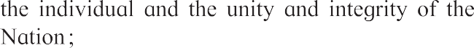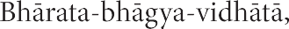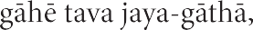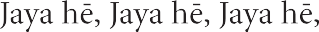

#### Preface

Dear Students,

A most hearty welcome to Std VII. We are happy to place this textbook ‘**English Balbharati**’ in your hands.

English has been a part of your studies since Std I. So far, you have learnt to use English for communication in most situations. You have enjoyed some interesting stories and passages in the previous textbooks. You have completed many projects. You have read the works of many well-known authors. Now that you are in Std VII, you will do all this and also learn to use English with a better understanding of the language and the way it is used.

English is not just a subject in your curriculum. It is the medium through which you learn all other subjects. A good command over the language will make it easier for you to study other subjects, too. Our main aim is to help you use English with confidence. We want you to be able to ask questions, gain knowledge and new skills, be creative and to spend your free time joyfully. That is why, we want you to take part in all the activities and exercises in the ‘Warm up’ and ‘English Workshop’ sections without feeling shy. Talk to your teacher freely about the problems and difficulties you face while studying this textbook. Many of the activities are designed to show you ways of thinking and learning on your own. The more you use them, the better you will learn.

We will be happy if you share your feelings about the contents of this book with us. We hope you enjoy studying it throughout the year.

Wish you all the best in your studies !

**Pune**



**Date :** 28 March 2017

Gudi Padwa Indian Solar Year : Chaitra 7, 1939

**(Dr Sunil Magar) Director**

Maharashtra State Bureau of Textbook Production and Curriculum Research, Pune.

#### English Balbharati - Standard Seven - Learning Outcomes

**Suggested Pedagogical Processes Learning Outcomes**

**The learner may be provided opportunities in pairs groups/ individually and encouraged to–**

* consciously listen to songs/poems/stories/prose texts in English through interaction and being exposed to print-rich environment
* participate in different events/ activities in English in the classroom, school assembly; and organised by different institutions
* listen to English news and debates (TV, Radio) as input for discussion and debating skills
* watch and listen to English movies, serials, educational channels with sub-titles, audio-video materials, teacher reading out from materials and eminent speakers
* share their experiences such as journeys, travelogues visits, etc. in pairs /groups
* introduce self, conversewith other persons,participate in role play / make speeches, reproduce speeches of great speakers
* summarise orally and in writing a given text, stories, or an event
* learn vocabulary associated with various professions (for example, cook, cobbler, farmer, blacksmith, doctor etc)
* read stories / plays (from books/ other sources in English) and locate details, sequence of ideas and events and identify main idea
* use material from various sources in English and other languages to facilitate comprehension and co- relation
* understand the rules of grammar through a variety of situations and contexts focussing on noun, pronoun, verb, determiners, time and tense, passivisation, adjective, adverb, etc.
* interpret tables, charts, diagrams and maps, and incorporate the information in writing
* think critically on inputs based on reading and interaction and try to provide suggestions/solutions to the problems raised. (The themes could be social issues, environment problems, appreciation of culture and crafts)
* refer sources such as dictionary, thesaurus and encyclopedia to facilitate reading
* read text, both familiar and unfamiliar, and write answers for comprehension and inferential questions
* take dictation of a paragraph with a variety of sentence structures.
* draft, revise and write with appropriate beginning, middle and end, along with punctuation marks
* know the features of various types of writing: messages, emails, notice, letter, report, short personal/ biographical experiences etc.
* use ICT (Net, mobile, website, Youtube, TED talks etc) to browse for information, for projects/PPT discussion, debate etc.
* attempt creative writing, like stories, poems, dialogues, skits etc.
* visit a language laboratory
* read/write a book review.

**The learner–**

* + 1. Listens attentively in the classroom.
    2. Understands speeches, announcements, stories etc about familiar topics/situations.
    3. Finds specific details, facts, information from a speech, story, conversation etc.
    4. Remembers/ recalls important facts/details/main points after listening to a programme.
    5. Predicts the remaining part of a sentence, the next sentence, etc.
    6. Carries out a complex /long process with the help of oral instructions.
    7. Thinks critically about what she/he has heard (decides whether it is true or false, relevant/ irrelevant, logical/illogical etc.)
    8. Draws his/her own inferences from what is presented.
    9. Verifies experiences/information being presented with his/her own observations/experiences/ previous knowledge.
    10. Participates in different activities in English such as recitation of a poem, monologue presentation, role play, skit, drama, narration of story, joke or incident, speech, quiz organised by school with proper pronunciation, pause and intonation.
    11. Frames questions/queries/requests politely.
    12. Responds to different kinds of instructions, requests, and directions in varied contexts.
    13. Communicates one’s feelings / emotions appropriately.
    14. Presents a report based on a survey, notes, information gathered from other resources.
    15. Uses appropriate body language, gestures and facial expressions while speaking.
    16. Answers queries, provides directions etc. clearly.
    17. Retells something in his/her own words.
    18. Prepares a speech by arranging the points systematically and presents it.
    19. Creates a dialogue / story/ skit as a pair/ group activity.
    20. Makes a short speech on a formal occasion.
    21. Speaks about excerpts, dialogues, skits, short films, news and debate on TV and radio, audio- video programmes on suggested websites.
    22. Reads simple passages on familiar topics.
    23. Understands the literal as well as the suggested / implied meaning.
    24. Understands the mode of communication – notice, formal/ informal letter, application forms, personal notes, diaries, essays, blogs.
    25. Reads/Writes a book review.
    26. Refers dictionary, encyclopedia on the internet to get required information.
    27. Guesses the meaning of a word / expression from the context.
    28. Learns new words, expressions and enrich his/her vocabulary through reading.
    29. Reads to seek information in print/ online notice board, sign boards in public places, news paper, hoardings etc .
    30. Remembers and recalls a complex set of written communication.
    31. Makes use of reading to improve his/her writing.
    32. Develops respect for one’s identity as an Indian.
    33. Writes neatly and legibly and correctly.
    34. Attempts calligraphy and decorative writing.
    35. Reviews and if necessary corrects his/ her own work as a matter of habit.
    36. Fills forms correctly.
    37. Prepares a formal invitation using a given format.
    38. Prepares posters on various themes.
    39. Describes people, places, objects, landscapes
    40. Translates literary pieces from the mother tongue into English and from English into the mother tongue.
    41. Prepares/compiles bilingual glossaries and other reference materials including graphics.
    42. Finds the required information on the internet.
    43. Finds the required pictures, video clips, films etc on the computer/internet.
    44. Handles various forms of digital material (eBooks, audio books, interactive materials, language games etc).
    45. Understands the features available on a website and uses them properly.
    46. Understands computer etiquettes (regarding

etc effectively.

* + 1. Writes a clear set of instructions.

passwords, email etc).

* + 1. Identifies and uses subject and predicate,
    2. Reports an event/happening using an appropriate format - a news item, a personal observation (diary) etc.
    3. Organises sentences coherently in English with help of verbal and visual clues.
    4. Prepares outlines for an essay, a short note, a short story etc. (arrange the major and minor points coherently and systematically.)
    5. Writes an essay.
    6. Describes a process / the working of a device in step by step and to the point manner.
    7. Prepares a conversation/dialogue as a group activity or individually.
    8. Attempts creative writing in different forms- stories, poem, skits, dialogues, cartoons, jokes, playlets etc.
    9. Writes dialogues from a story and story from a dialogue.
    10. Uses first person/third person appropriately in narratives and writing.
    11. Uses appropriate grammatically forms in communication (For example, noun, pronoun, verb, determiners, time and tense, adjectives, adverbs etc).
    12. Makes notes for personal references while listening/ reading.
    13. Labels various diagrams appropriately.
    14. Writes appropriate captions to photographs, pictures and diagrams.
    15. Understands and uses the organisation of graphic presentation.
    16. Transfers verbal information to graphic format such as a chart, a table, a graph, flow charts, a web, a map etc.
    17. Compiles lists of useful words, expressions, idioms, definitions, formulas etc.
    18. Identifies which learning style/strategies work best for oneself and uses them.
    19. Classifies given information using different criteria.
    20. Provides English/ mother tongue equivalents for certain terms correctly while speaking/ writing English.
    21. Translates different types of informative texts from the mother tongue into English and from English into the mother tongue.

subject, verb and object (direct/indirect) complement, adverbial, transformation (framing questions).

* + 1. Transforms a statement into question.
    2. Understands and uses root-words, prefix, suffix, synonyms, antonyms, homonyms.
    3. Uses punctuation marks such as full stop, comma, and question mark, exclamation mark, hyphen, dash.
    4. Learns the literary devices such as simile, metaphor, alliteration, onomatopoeia, consonance.

**Language Study**

**Parts of speech :**

* + - * Nouns : Common and proper nouns; Singular / plural / irregular; concrete / abstract
      * Conjunction and interjection
      * Verbs : main - auxiliary- modal verbs; transitive and intransitive verbs

**Sentence structures :**

* + - * Subject and predicate

Subject, verb and object (direct /indirect) complement

adverbial

transformation (framing questions)

**Vocabulary and word building :**

* + - * Root word, prefix, suffix, synonyms, antonyms, homonyms

**Punctuation :**

* + - * Full stop, comma, question mark, exclamation mark, hyphen, dash

**Literary devices :**

* + - * Simile, metaphor, alliteration onomatopoeia, consonance

### Contents

**Unit One**

* 1. Past, Present, Future 1
  2. Odd One In 3
  3. In Time of Silver Rain 8
  4. The King’s Choice 10
  5. Seeing Eyes Helping Hands 16
  6. A Collage 21

Unit Two

* 1. From a Railway Carriage 22
  2. The Souvenir 24
  3. Abdul Becomes a Courtier 30
  4. How doth the little busy bee 35
  5. Learn Yoga from Animals 37
  6. Chasing the Sea Monster 43
  7. Great Scientists 49

Unit Three

* 1. Tartary 55
  2. Compere a Programme 58
  3. A Crow in the House 64
  4. The Brook 68
  5. News Analysis 71
  6. Think Before You Speak ! 75

Unit Four

* 1. Under the Greenwood Tree 79
  2. Unke Munke Timpetoo 81
  3. The Red-Headed League 86
  4. Home Sweet Home 95
  5. Seeing Eyes Helping Hands 97
  6. Papa Panov’s Special Christmas 99

About the cover : The ‘Blue Mormon’ is our State butterfly. The cover shows blue mormons enjoying nectar from books which have blossomed on the plants. On the title page, we see the same butterfly mud-puddling - drawing salts from mud.



## Past, Present, Future

Tell me, tell me, smiling child, What the past is like to thee?

‘An Autumn evening soft and mild With a wind that sighs mournfully.’

Tell me, what is the present hour? ‘A green and flowery spray

Where a young bird sits gathering its power To mount and fly away.’

And what is the future, happy one? ‘A sea beneath a cloudless sun;

A mighty, glorious, dazzling sea Stretching into infinity.’

- *Emily Bronte*

* * *

1

Emily Brontë and her sisters were well-known authors who lived in the nineteenth century. Emily Brontë uses nature to talk about her thoughts, feelings and ideas in many of her poems. This poem about time is presented in the form of a dialogue between the poet and a happy child. For the child in the poem, the past was a pleasant time, but sadly, we cannot go back to it. The present is a time when you prepare for the future which is unknown but exciting.



**ENGLISH WORKSHOP**

1. Read the poem aloud using proper rhythm and intonation.

1. Link the items in the three columns properly.

#### A B C

The past

A sea beneath a cloudless sun

A pleasant time which has ended

The present hour

A soft and mild autumn evening

An exciting, thrilling time which has no end.

The future

A green and flowery spray where

a young bird sits

A time, full of life in which you gather strength

1. Find the meaning of the following words.

 thee  mournfully  spray  mighty

1. Write the adjectives that are used to describe the following.  evening  spray  sea
2. Write one line about each of the following with the help of the poem.  wind in the autumn evening  young bird on the spray  the sea
3. Language Study :

 A **simile** is an imaginative comparison of two different things which have something in common. A simile always includes the words ‘as’ or ‘like’. For example : as tall as a tree, as lovely as a flower

 A **metaphor** is an imaginative expression that refers to someone/something as another person/thing. It shows that the person or thing has some quality of that other person or thing. The words ‘as’ or ‘like’ are not used in a metaphor. For example : He is a gem of a person. Time is money. Books are our friends. The clouds are white sheep.

There are three metaphors in the poem. Can you find them ?

2

## Odd One In

“How was the first day of school?’ asked Mother as Rima sat down for dinner.

“Okay,” Rima shrugged. “No lessons. Just settling in.”

“Any new girls in your class?” enquired her father, Mr Sen.

“Only one - Malti - and she is funny,” grimaced Rima as she helped herself to the salad.

“Why do you say that?” asked Mr Sen.

“She can’t speak much English. She has come from another State,” sniffed Rima, naming one at the other end of the country.

“Oh ! Children from that State are supposed to be clever. They are specially good at maths,” said Mr Sen quietly.

“Well, this one does not seem smart at all. Oily hair, bindi and all. ‘Gud marning, Teeechurr,” mimicked Rima.

Her parents exchanged glances. Rima was their only child. They doted on her. But she could be insufferable at times.

“I do hope you and your friends will not make things too difficult for Malti,” sighed

Mr Sen as he rose from the table.

Rima and her gang had decided to do just that.

Next morning, the minute Malti entered the class, they all chorused, “Gud marning!”

Poor Malti. She did not realise that they were making fun of her. She beamed back at them and replied, “Gud marning!”

**Discuss the meaning in the context of the story.**

* settling in
* sniffed
* insufferable

**Discuss :**

 How did Rima decide whether or not Malti was smart ? What is your opinion ?

 Do Rima and her parents share the same attitude ?

How do we know

that ?

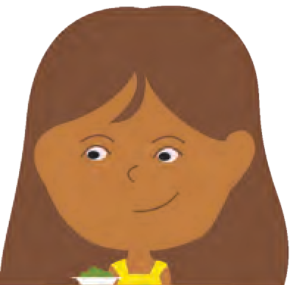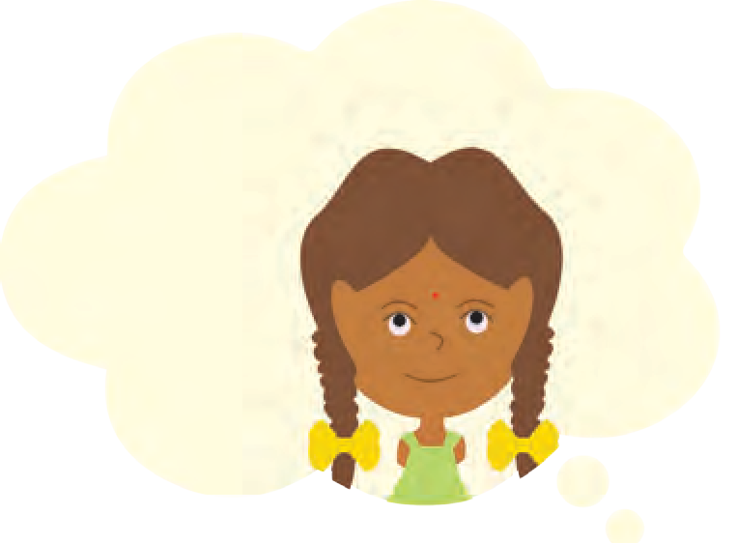

3

Shahnaz giggled. “Why do you put so much oil on your hair ?” she asked rudely.



 Guess what Malti

was about to say when Teacher entered.

**Discuss the difference in the meaning of**

**the following words :**

* smart
* confident
* snob
* recounted : told
* atrocious : Here, it means of very poor quality
* snidely : in a nasty manner
* jeer : make rude remarks in a loud voice.

4

Malti looked offended but did not reply.

“And the skirt - soo l-o-o-n-g,” said Clare cattily.

Malti flushed. She was about to say something when Teacher entered. As the class progressed, everyone was surprised to see Malti raise her hand whenever Teacher asked a question.

“Yes, Malti, you answer,” said Teacher.

Malti answered correctly and Teacher nodded in appreciation.

When Rima recounted this at home, her mother said, “Sounds like a clever girl.”

“What is the use?” said Rima uncharitably. “Her English is so atrocious.”

“The same may be said of your Hindi,” countered Mr Sen sharply. He was getting quite sick of Rima’s attitude.

Even Mrs Sen did not like it. That night Rima’s parents discussed the matter.

“We put Rima into a good school to make her smart and confident. I am afraid she is turning into quite a little snob!” said Mr Sen sadly.

The following Saturday was the Inter-House singing competition. Rima, who was participating in the English song category, was surprised to see Malti’s name in the list of participants for the Hindi song category. “Oily plaits sings also,” she said snidely to Clare.

“Croaks, you mean,” giggled Clare. They were to be proved wrong.

Malti sang beautifully. She had a melodious and well-trained voice. Rima and her gang had

decided to jeer when Malti sang, but there was such absolute silence, they did not dare to. They

were sure to get caught. When Malti finished, the Principal was the first one to start clapping, followed by the teachers and students.

No one was surprised when Malti won the first prize. Rima did come first in her category; somehow, she felt no joy.

**Guess the meaning of :**

* forte
* belied
* befriended

As the term progressed, it was abundantly clear to all that Malti was a bright child. She was quiet, studious and intelligent. She fared well in sports as well as in studies. Her forte was mathematics. Her simple appearance belied a sharp and nimble brain. Slowly, many of the girls began seeking her help in mathematics. Help which she readily and cheerfully gave. The teachers had liked the respectful, intelligent girl from the beginning. Now girls from the class also befriended her.

Not Rima and her clique though. They stubbornly disliked Malti. They were a stylish lot and nothing that Malti did could alter the fact that she was not their type. They never lost a chance to poke fun at her, particularly her English.

Malti felt bad about their behaviour. One day, she was on the verge of tears when Rima mocked at her mercilessly because she said “aks” instead of “ask”.

Her voice

trembling, Malti said, “I know my English is weak. Yours is good. Please, will you help me to improve it?”

“I won’t be able to help you, my dear,”

replied Rima with an exaggerated accent. “Speaking proper English isn’t easy for you countrified types!”

**Think and answer :**

 Why did Rima feel no joy even though she came

first in her category ?

* clique : a small group of friends who do not allow others to join them.

5

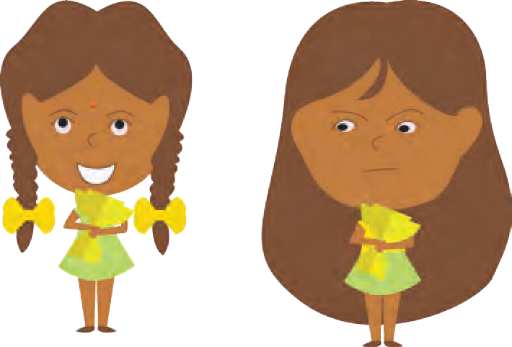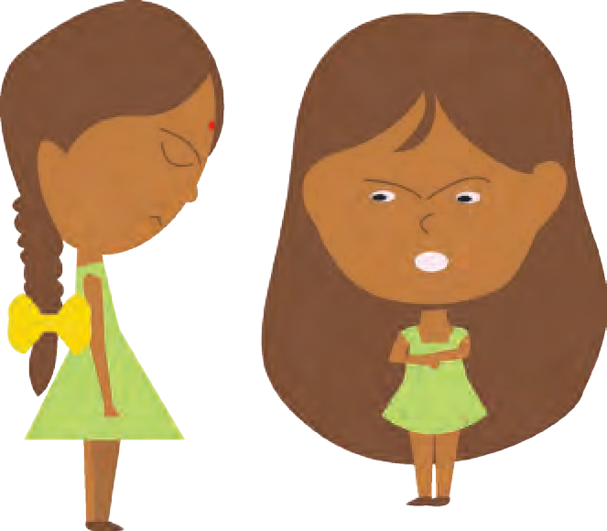

 Name the friends in Rima’s clique.

* roundly : Here, it means ‘in

an emphatic manner.’

This is an extract from the story ‘Odd One In’.

Can you imagine

what happened next in this story of Rima

and Malti ?

Try to complete the story on your own or by discussing it with your friends.

Malti’s face turned red. She wanted to retort but could not find the right words. She burst into tears and ran off.

“That was horrid, Rima,” said Shahnaz. “Yes,” agreed Neha and Clare roundly.

Rima was shocked. Her own friends had turned against her! She walked off in a huff.

Mrs Sen found her subdued over lunch but decided not to ask anything. Rima knew that she had behaved very badly. She was too proud to admit it - even to herself.

- *From ‘Odd One In’ by Tithi Tavora*

* * *

**ENGLISH WORKSHOP**

1. Read aloud the conversations in the story turn by turn.
2. Write about Malti and Rima using the following points :

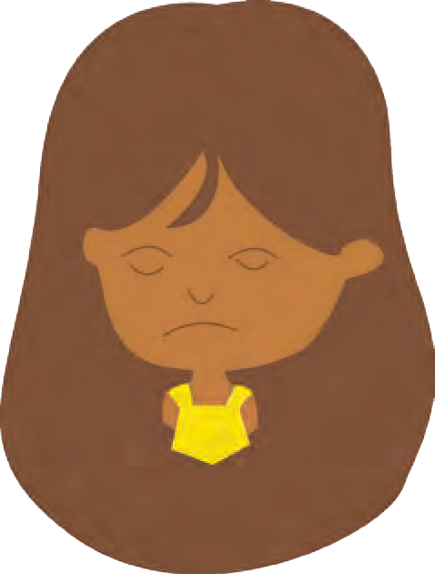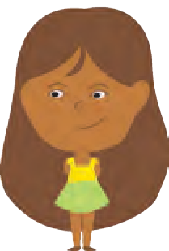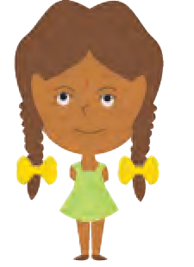

Malti Rima

* + Appearance... • Appearance...
  + Studies... • Studies...
  + Singing... • Singing...
  + Attitude to others... • Attitude to others...
  + Weak points... • Weak points...

Use details from the story and your own imagination when you write the above descriptions.

1. Imagine you are Malti. Write about any one event in the story from Malti’s point of view.

6

1. How do you behave with your classmates ? Write about your attitude and behaviour in the appropriate column.

(Some actions : • Ask others for help • Refuse help • Judge others by their appearance • Judge others by their accent.)

|  |  |  |
| --- | --- | --- |
| **Always** | **Sometimes** | **Never** |
|  |  |  |

1. **Talk about** : (a) your strengths (b) your weaknesses (c) the changes that you would like to see in yourself (3 each).
2. **Discuss** : Is it necessary to develop a good accent ? Why ? What efforts can you take to improve your pronunciation ? With your teacher’s help, find out how to use online dictionaries for the purpose.
3. List all the adverbs that end with ‘-ly’ from the passage.
4. Language Study : **Types of nouns :** You know that a noun is a word used as the name of a person, place or thing. The names given to particular persons, places, animals etc. are **proper nouns** and the rest are **common nouns**. For example, ‘Ria’ is a proper noun, because it is the name of a particular person. But, ‘girl’ is a common noun, as it is not the name of a particular person. ‘Ahmednagar’ is a proper noun, because it is the name of a particular place. ‘Town’ is a common noun, because it is not the name of a particular place.

**Nouns**

**Common nouns Proper nouns**

girl

pencil

boy

bag

town river table

road, etc.

Sangeeta

Sahyadri

Rahul

London Nashik

Pravara, etc.

* + Write at least 5 common nouns and 5 proper nouns each. Proper nouns are always written with a capital letter at the beginning. Can you think of proper nouns that include two or more words ? How are they written ? Find at least ten such nouns. Examples : Seva Hospital, The Times of India.

7

## In Time of Silver Rain

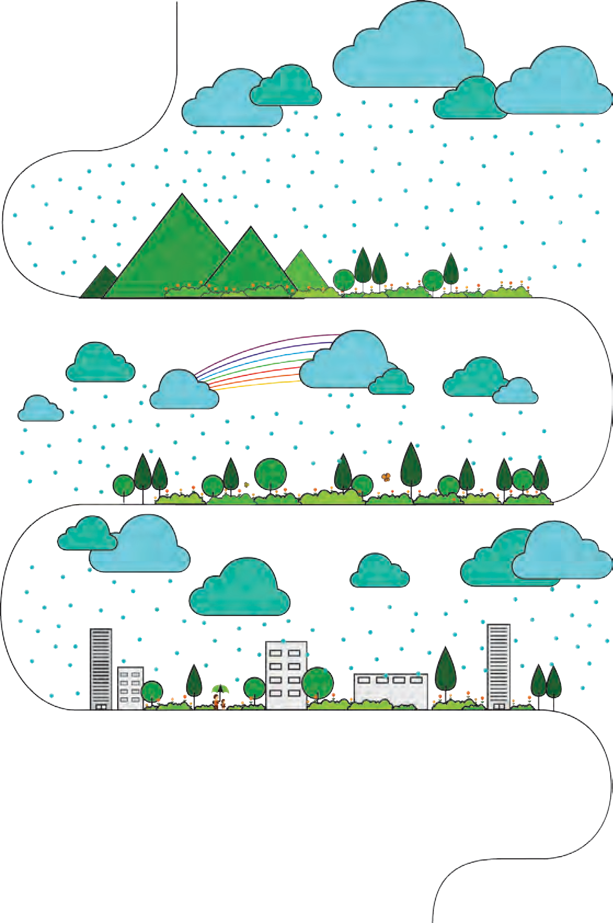

In time of silver rain The earth

Puts forth new life again, Green grasses grow

And flowers lift their heads, And over all the plain

The wonder spreads. Of life,

Of life, Of life!

In time of silver rain The butterflies

Lift silken wings

To catch a rainbow cry, And trees put forth

New leaves to sing

In joy beneath the sky As down the roadway Passing boys and girls Go singing, too,

In time of silver rain When spring

And life Are new.

*- Langston Hughes*

* * *

8



Langston Hughes was an American writer and activist, who won many awards and honours for his work. He started a new style of writing poetry in which rhythm and spontaneous expression are important. In this poem, he describes how rain brings joy and life.

**ENGLISH WORKSHOP**

1. Find the pairs of rhyming words used at the end of the lines in the poem.
2. Read the poem aloud using proper intonation.
3. If you were to draw a landscape on the basis of this poem, what elements will you show in it ? What colours will you use ?
4. The special arrangement of short lines makes you think about every detail. If you write the sentences in the usual manner, it does not have the same effect. For example, the first stanza would be something like ‘The earth puts forth new life again; green grasses grow and flowers lift their heads and the wonder of life spreads all over the plain in time of silver rain.’

**Now try the following :**

Write one or two sentences about something beautiful, using your own experience or imagination. Then rearrange the words in the sentences in a poetic form. You may write about a beautiful day, a beautiful night, a stream, a crop standing in a field, a graceful bird or animal, etc.

1. Fill in the following blanks with reference to the poem.

‘In time of rain when spring and life are ............, the butterflies lift ............

wings to catch a ............ cry and trees put forth ............ leaves to sing in

............ beneath the sky as ............ boys and girls too ............ singing down the roadway’.

1. **Think and answer :**
   1. Is the poet talking about heavy rains in the rainy season or rain that has come after a long time ?
   2. Are the boys and girls happy that it is raining ?
2. Find out the following with the help of your teacher and the internet.

* Seasonal Rains (monsoon) in India and other countries.
* Rain in countries like UK which experience spring-summer-autumn-winter.

1. **Talk about** your favourite season. (A one minute activity.)
2. Language Study : **Alliteration :** When the same sound occurs at the beginning of two or more words in the same line, it is called alliteration.

Example : Nayna needs new notebooks.

Find an example of alliteration from the poem. Collect other examples of alliteration.

9

## The King’s Choice



 Guess the

meaning of ‘fierce’ in this context.

**Think and answer :**

 Why must a king have a court ?

 What qualities are necessary in the following ? Why ?

* king
* adviser
* bodyguard
* messenger

 What is oath of

loyalty ?

 Write and read aloud the oath that each of the courtiers must have taken ?

10

THERE was once a lion who was king of the forest. He was big and strong and very fierce.

All the other animals in the forest called him king. They brought him gifts from every corner of the forest.

But the more the lion had, the more he wanted. ‘A king must have a court,’ he said to himself

one day.

He called a fox to his side.

“You are known to be a wise and clever creature, fox,” said the lion. “I want you to be my adviser.”

“Thank you, Your Majesty,” said the fox, bowing low.

The lion next called a leopard to his side. “You are known to be watchful and swift of

foot, leopard. I want you to be my bodyguard.”

“Thank you, Your Majesty,” said the leopard, bowing low.

The lion then called a vulture to his side. “You are a bird, vulture, and can fly high. You

are to be my messenger.”

“Thank you, Your Majesty,” said the vulture, bowing low.

The fox, the vulture and the leopard took an oath of loyalty to the king. The king promised to give them food and protection.

For some time all went well in the court of the lion king. The three courtiers never opposed the king. His wishes were law. Whenever he roared, they stood in awe. Whenever he took a walk, they followed him.

When the lion king went hunting, they found the animals for him to kill. And after he had his

meal, he left the remains for them. So they always had enough to eat.

One day the vulture came back from a flight. “Your Majesty, have you ever eaten a camel?”

he asked. “It is very tasty. I ate it once in the

desert.”

The lion had never seen a camel, but he liked the idea of trying camel’s meat.

“But where can we get a camel?” he asked. “There is a desert some miles away.” said the

vulture. “I was flying over it when I saw a lone

camel not far away. It looked big and fat.”

The lion looked at his other advisers. They were wise and experienced. He wanted their opinion. Now the fox and the leopard did not know the desert. But they did not want the vulture to seem wiser than them. So they said, since it was the vulture’s idea, he should lead the way.

Early next morning the lion and his court started off on the camel hunt.

They reached the edge of the desert easily. But after they left the shelter of the forest, the day became very hot. The sun shone down with fire-hot rays.

* lone : only one

 Why was the vulture told to lead the way ?

**Think and answer :**

 Why had the lion

never seen a

camel ?

 What advice did the fox and the leopard give ? Was it based on good and sound

thinking ?

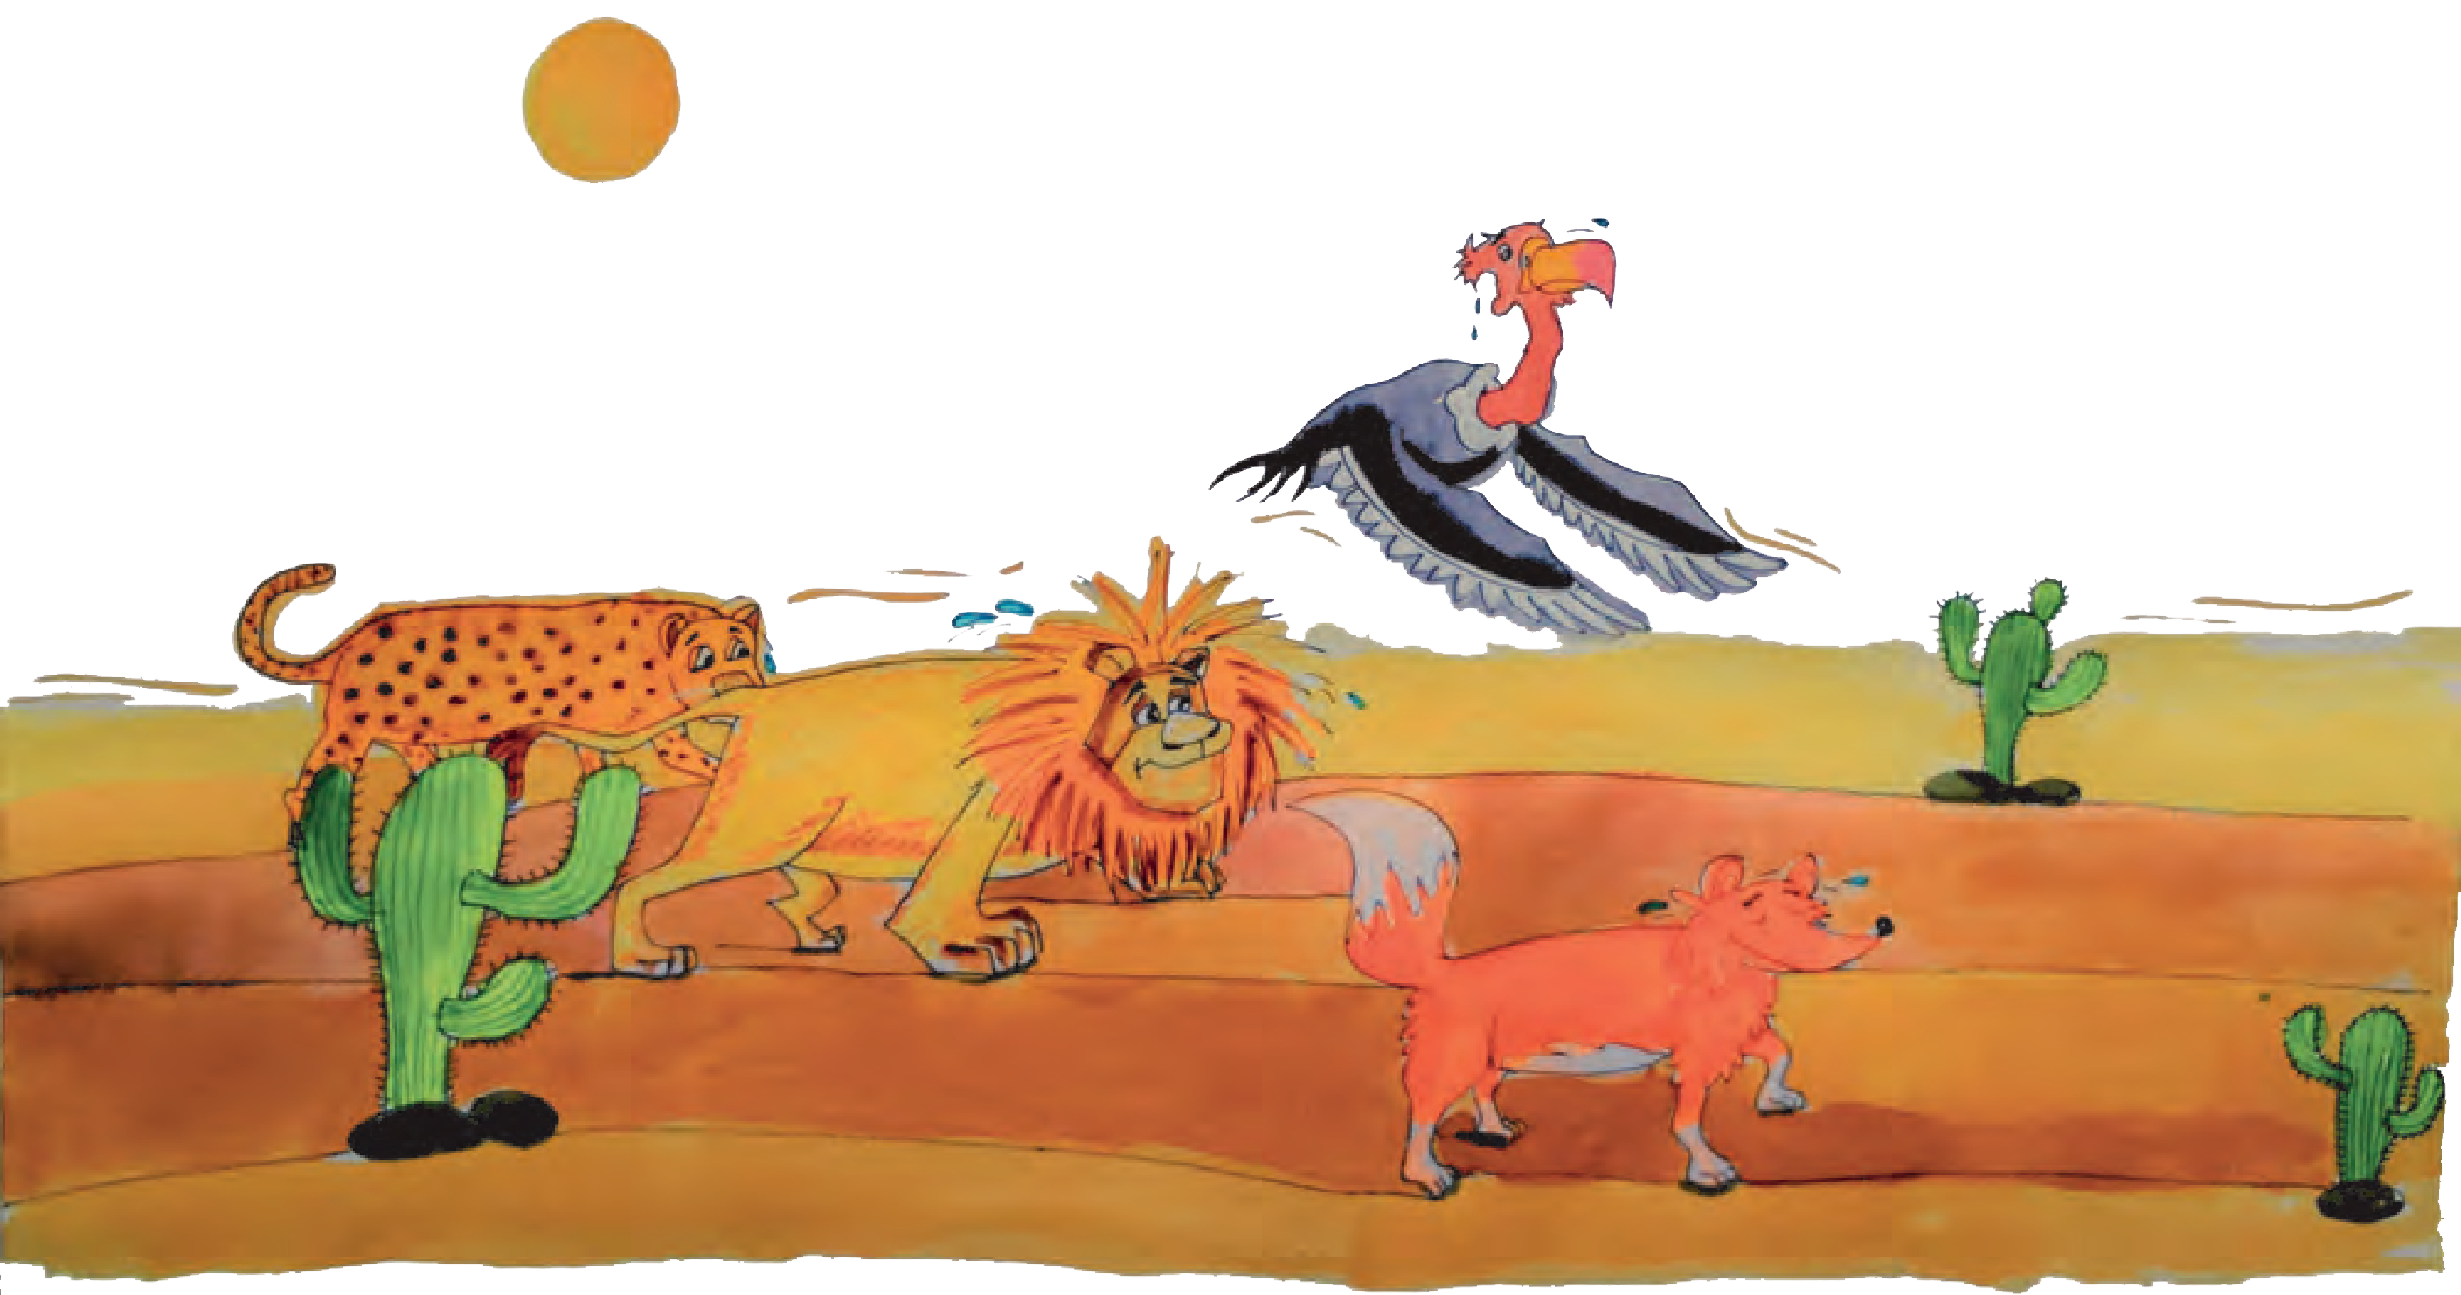

11

High up in the cooler air the vulture flew. “Hurry along,” he called, “the camel is not far



 Do you think the

vulture was enjoying the search ?

 Do you think the king’s decision to go back was right ?

 Can you guess

the plan that the fox had thought of ?

 Why does the fox address the camel as ‘friend camel’ ?

 What qualities of

the courtiers emerge in this part of the story ?

12

off.”

But the lion could not hurry any more. The hot sand had burned his paws. He could go no farther.

“Stop!” he shouted to the others.

“Let us go back to the forest. I do not care to try camel meat.”

The lion king’s advisers were frightened. The forest was far behind them and they did not know how to get the lion back home.

The leopard wanted to run away.

The vulture wanted to watch and wait and eat the lion later on.

But the clever fox thought of a plan. Off into the desert he ran saying, “I will bring some help.” After running for some time, the fox found the

camel. The camel was indeed surprised to see him.

“Hurry up, friend camel,” said the fox. “Our king wants you at once.”

“Your king ?” said the camel. “Who is that ? I do not know any king. I only know my master, for whom I carry goods across the desert.”

“Our king, the lion, has killed your master,” said the fox. “Now you are free, and the lion has invited you to live at his court. Come along.”

The camel followed the fox.

When the fox and the camel reached the lion’s camp, the vulture and the leopard were surprised. Even the lion looked pleased, in spite of his burned paws.

The camel was presented to the king. He agreed to serve the lion in return for a home at his court. “Get on the camel’s back, Your Majesty,” said

the fox. “We will return home.”

The lion at once jumped on to the camel’s back. His courtiers, the fox and the leopard, jumped

up behind him. And with the vulture flying ahead as a guide, they set off on the long journey back to the forest.



 The fox, the

leopard and the vulture have the same thought about the camel. Why is it so ?

 Did you expect

the lion to be kind to the camel ? Do you think his decision was right ?

 Why did the courtiers have to obey the king ?

 Were the courtiers

being loyal to their king ?

Discuss.

13

When the travellers reached the forest, they were all tired and hungry.

The fox, the leopard and the vulture looked at the camel. Then they looked at each other and smiled hungry smiles.

They had brought the camel for the king’s dinner. Now it was time for the feast.

The lion king knew what his courtiers were thinking. He called the camel to him.

“Friend camel,” he said, “I have to thank you for saving my life. You are welcome to live at my court as long as you like. I promise you my protection.”

The lion’s courtiers were shocked. Had they not risked their lives so that he could try camel meat ? And the king wanted to let the camel live !

The courtiers were not pleased with his decision.

Yet they could do nothing.

Now the lion’s paws were so badly burnt that he could not go hunting. But that did not keep him from growing very hungry indeed.

“Fox ! Leopard ! Vulture !” he shouted.

“Don’t you see that I am ill and hungry ? Go and get me some food !”

The courtiers had to obey the king. So out they went. But they did not go far. They sat down in a safe place and discussed what they could do.

“I know,” said the fox after a while, “we shall make the camel ask to be eaten.”

He told the others of his plan. They all agreed, so back they went to the king.

First the vulture stepped forward. “Your Majesty,” he said, bowing low, “we have found no food. But we cannot let Your Majesty suffer. I am a poor creature. Eat me.”

The fox pushed the vulture aside, “I have more meat on me,” he cried. “Eat me, Your Majesty.”



 What qualities of

the camel are seen in his speech ?

**Think and answer :**

 Why did the lion laugh to see the courtiers go ?

 Is ‘friend’ a position at a court ? How is it different ?

14

Now the leopard rushed forward. “I am not much good,” he cried. “But I could make a meal for the king.”

The camel listened to all these offers. He must do as much, he thought.

“Your Majesty,” he said. “I too am willing to give my life for you. Please eat me instead of these old friends of yours who will be more useful than I am.”

This was what the fox, the leopard and the vulture were waiting for. They prepared to jump at the camel. But the lion stopped them.

“You are all good and loyal subjects,” he said. “My heart is touched by your offers. I accept them all. I shall eat you in the order in which you offered yourselves.”

The vulture, the fox and the leopard were shocked.

Away flew the vulture. Away ran the fox and the leopard. They were never seen in the forest again.

The lion laughed to see them go. Then he turned to the camel and said, “You have been loyal and good. You shall be my friend as long as we are alive.”



The camel was happy and grateful. The lion thought to himself, ‘To be king is good. But to be kind is better.’

- *Shankar*

(*From* ‘*Folk Tales Retold*’)

* * *

‘To be king is good.

But to be kind is better.’

**ENGLISH WORKSHOP**



1. Write a character sketch of each of the animals. Write about their **actions** and **thoughts** and the **qualities** that emerge through

them. You may present the sketch in the form of a graphic.

1. Using your imagination, write more sentences in the same pattern:
   1. But the more the lion had, the more he wanted.
   2. Whenever he took a walk, they followed him.
   3. To be king is good. But to be kind is better.
2. Turn the story into a play as a group activity and present the scenes in the classroom.
3. This story takes an unexpected turn when the lion decides to spare the camel’s life. Choose any fable, story that you like and rewrite it giving it an unexpected turn.
4. **Talk about** the good qualities of any one person you do not like. (You need not name the person.)
5. Language Study : **Common nouns -1 :** Some things, animals etc., that is, some nouns can be counted. They are called **countable nouns**. Some common nouns stand for something that cannot be counted. They are called **uncountable nouns**. Countable nouns have two forms. A noun that shows one person or thing, etc. is said to be in the **singular**. For example, ‘boy’, ‘girl’, ‘dog’, ‘tree’, ‘chair. A noun that shows more than one person or thing, etc. is said to be in the **plural**. For example, ‘boys’, ‘girls’, ‘dogs’, ‘trees’, ‘chairs’.

**Common nouns**

**Countable nouns Uncountable nouns**

hair, water, gold, sky, fun, etc.

**Singular Plural**

word, country, words, countries,

game, watch, etc. games, watches, etc.

Note the expressions ‘a slice of bread’, ‘strands of hair’, ‘two glasses of water’, ‘a cup of milk’ and ‘a bit of fun!’. Here, we do not say ‘breads’, ‘hairs’, ‘waters’, ‘milks’, ‘funs’, etc.

* Find five countable nouns from the passage and write their singular and plural forms.
* List the units that we use to measure the following : water, milk, distance, weight.

15

## Seeing Eyes Helping Hands

Everyone in New Vision High School was busy. The inauguration of the project ‘Seeing Eyes, Helping Hands’ was scheduled to take place next week. It was getting late for sending out the invitations. At last, the Principal herself prepared the formal invitation. The art teacher and her students made copies of it. Here is a sample of what they did :



**A : A formal invitation**

* Find the different ways in which you can send this invitation using the internet.

16

Also, a notice was put up on the school notice board to invite the students and parents to the inaugural function :



**- NOTICE -**

Students of Std VII and their parents are invited to the

**Inauguration**

of the Project

**‘Seeing Eyes, Helping Hands’**

at the hands of

**Smt. Vimala Naik**

Former Principal of New Vision High School and

President, Sahayak Samaj.

**Dr A. M. Chaudhary, Dean,**

New Life Medical College and Hospital

**has kindly agreed to preside over the function.**

**Time :** 10 am to 11 am Sunday, 9 July 2017

**Venue :** Assembly Hall New Vision High School, Off Main Street, Girgaon.

**B : A written notice**

* + Many times, the school authorities have to communicate with your parents. How is it done in your school ? How are written communications sent ?
  + With your teachers’ help, get two or three specimens of the notices / announcements put up on the school notice board.

17

Teachers made phone calls to some special invitees. Here is a sample of one such telephone conversation :



Receptionist : Hello, Girgaon Times.

Teacher : Good morning, I am Vishwas Ajinkya from New Vision High School. Could I speak to your news editor, Mr Shashank, please ?

Receptionist : Just a sec.

Teacher : Thank you.

News Editor : Hello, Mr Ajinkya. Shashank speaking. How are you ?

Teacher : Fine. How are you ?

News Editor : Fine.

Teacher : Mr Shashank. I have a request. I am calling from New Vision High School. Our school is starting a new social work project. The inauguration is on the coming Sunday. We are sending you the official invitation today.

News Editor : I see.

Teacher : Our idea is to make our students aware of their social responsibilities. It will be a big project and we hope it will set a trend for all schools to follow. We would like your paper to cover the function prominently.

News Editor : Well, this Sunday is going to be a busy day. But, as you say, the project is an important one. It should get good publicity. When did you say is the function ?

Teacher : This Sunday, at ten in the morning.

News Editor : Fine, I’ve made a note of it.

Teacher : Thank you very much.

1. **: An oral invitation**

18

Students passed on the message to their parents. Here’s a sample :

“Mummy, you and Daddy are invited to our school on Sunday, the ninth,” said Sameer.

“What’s the occasion?”

“Our school is going to run a project called ‘Seeing Eyes, Helping Hands’. There’s a function to inaugurate it on Sunday at 10 sharp. Students of seventh standard are invited with their parents.

“Where is it ?”

“In the School Assembly Hall.” “How long will it be ?”

“About an hour. Ms Naik will be there, too. She is going to inaugurate it.”

“I see. And what’s this project about ?”

“Oh, we are all going to visit places and work for others, turn by turn. They’ll explain that on Sunday.”

“So, you are going to participate in it, aren’t you ?”

“Yes, Mummy.”

“Let’s see. Daddy and I can’t both go, but one of us will accompany you.”

“That would be nice, because Mr Ajinkya has specially asked all the students to tell their parents about it.”

1. **: Another oral invitation**

19

**ENGLISH WORKSHOP**



1. This passage contains four different types of invitations. They are :

**A :** A formal invitation **C :** An oral invitation

**B :** A notice **D :** Another oral invitation

* + Read each invitation carefully, keeping in mind the list of eight questions given below. Note the answers in your notebook. Verify that the formal invitation ‘A’ covers all the eight points.
    1. Who is sending / giving the information ?
    2. What is the programme ?
    3. What is the name of the project ?
    4. Who will inaugurate it ?
    5. Who will preside over the function ?
    6. What time will the function start ?
    7. Where will it take place ?
    8. How many names get mentioned in the invitation ?
  + Now see which of these eight points are covered in the other invitations ‘B’, ‘C’ and ‘D’. Put tickmarks against the points that are covered.

|  |  |  |  |  |
| --- | --- | --- | --- | --- |
| **Points covered** | **A** | **B** | **C** | **D** |
| (1) | 🗸 |  |  |  |
| (2) | 🗸 |  |  |  |
| (3) | 🗸 |  |  |  |
| (4) | 🗸 |  |  |  |
| (5) | 🗸 |  |  |  |
| (6) | 🗸 |  |  |  |
| (7) | 🗸 |  |  |  |
| (8) | 6 |  |  |  |

1. **Prepare a formal invitation** for a function you have arranged at home. It should clearly state the following points :

* Who is inviting people to the function. • What the programme is.
* The date and time. • The venue. (The place where
* A polite request to attend the function. the function will take place.)

1. **Write an imaginary telephone conversation** in which you invite your friend to the above function.
2. Imagine someone has invited your family to a programme and you were the only person at home when the invitation was given orally.

**Write a note** (4-5 lines) to pass on the message to the other people in your family. Or, Write an imaginary conversation in which you pass on the message to your parents.

20

## A Collage

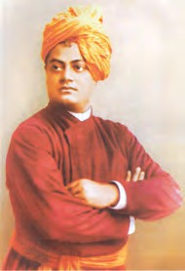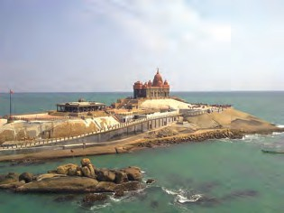

Swami Vivekananda, born Narendra Datta, was a great personality who made the world aware of the greatness of Indian philosophy. At the Parliament of World’s religions, he began his speech with “Sisters and brothers of America !” At these words, he received a two-minute standing

ovation. He emphasized the importance of selflessness and service to mankind. He is regarded as a patriotic saint.

Talk to yourself at

least once in a day... Otherwise you may miss a meeting with an excellent person in the world .

Whatever you think , that you will be. If you think yourself weak , weak you will be; if you think yourself strong, strong you will be.

* Gather information about your favourite great historical personality. You may use the internet. You may also gather photographs, pictures, etc. **Prepare a collage** using the pictures, inspirational quotes, and a brief description of the person’s importance. Hold an exhibition of your collages in the classroom.

21

## From a Railway Carriage



2

FASTER than fairies, faster than witches,

Bridges and houses, hedges and ditches;

And charging along

like troops in a battle, All through the meadows, the horses and cattle;

All of the sights

of the hill and the plain Fly as thick

as driving rain; And ever again,



in the wink of an eye,

Painted stations whistle by.

Here is a child

who clambers and scrambles,

All by himself

and gathering brambles;

Here is a tramp

who stands and gazes;

And there is the green

for stringing the daisies !

22

Here is a cart

run away in the road Lumping along

with man and load;

And here is a mill and there is a river.

Each a glimpse

and gone for ever !



*- R. L. Stevenson*

**ENGLISH WORKSHOP**

1. Read the poem aloud with proper rhythm. What does the rhythm remind you of ?
2. Find pairs of rhyming words from the poem.
3. Write the following :
   1. The sights seen through a railway carriage mentioned in the first stanza.
   2. The sights mentioned in the second stanza.
   3. The sights mentioned in the third stanza.
4. Think and answer:
   1. Why are the sights said to ‘fly’ ?
   2. Does the last line make you happy or sad ? Why ?
5. List the lines that begin with ‘Here’ or ‘And here’.

Also list the sentences or phrases that begin with ‘And there’.

These phrases and sentences tell us about things that appear one after the other

as the carriage moves. Can we tell which ones are closer to the train and which ones are at a distance ? How ?

1. Read the following :

* Charging along like troops in a battle. • Fly as thick as driving rain. Using your imagination, write one or two comparisons each with -
* like ............. • as as

1. Write about the sights you may see from a bus or an aeroplane. You may write it in the form of a short poem.
2. Find and read other poems of R. L. Stevenson using the internet.

Find other rhythmic poems about trains, in English or other languages.

23



* out of this world

: Here, the expression has dual meaning - it means ‘not found on the earth’ and also ‘extra-ordinary’

* panorama : a very wide view

**Think and answer :**

 In what time periods is the story taking place ?

 Where does Sayali live ?

24

## The Souvenir

With the tip of her nose pressed to the window of the space shuttle,

Sayali sat gazing at the view outside

for so long, still she didn’t seem to be contended. She had read the description of this view several times before and had seen this scene on the video too. But this was different! Reading the description was one thing, watching the pictures and videos captured by the camera was another but getting an opportunity to view that amazing panorama with your own eyes, being present physically right in the midst of it, was indeed an ‘out of the world’ experience ! No matter how long she sat gazing, her awe and wonder did not seem to abate.

The earth gradually appeared to get smaller and smaller in the sky. The azure blue sky was now looking jet black. The clouds had disappeared, the stars were shining bright.

* * *

This trip to the moon was exorbitantly expensive, but still Sayali’s mother had sent her on the trip.

‘In our childhood we could not even think of such long distance trips ! The longest trip meant going to Europe. If you are getting this opportunity, make the most of it.’ said mummy.

‘Oh! Mummy, Neha’s grandmother was saying that in their childhood, the longest trip for school children used to be only up to Delhi or Kolkata. It seems so funny, isn’t it?’ said Sayali laughing. Remembering the incident made her laugh even now.

Now the shuttle was getting closer and closer to the moon. Then it started orbiting the moon. In every 32 minutes, the shuttle completed one revolution round the moon.

Light and darkness followed each other in quick succession. The dome shaped settlements on the moon which resembled the igloos of the Eskimos were now visible.

After some time, Sayali’s shuttle made a slow, measured and safe landing on the moon. The door of the shuttle was opened and the children were escorted through an airtight tunnel to the settlement at the Neil Armstrong base.

The receptionist at the entrance to the base gave some instructions at the very outset.

‘I welcome you all to the Neil Armstrong base. To make your stay on the moon pleasant and comfortable, I would like you to take certain precautions. Listen carefully to my instructions and please follow them during your stay. You know that the gravitational force of the moon is 1/6 that of the earth. In the human settlements on the moon, a gravitational force equivalent to that of the earth has been artificially maintained; but outside those settlements, the gravitational force of the moon is at work. You will have to be extremely careful when you roam around there. The second point to remember is related to shopping on the moon. You all must be interested in carrying souvenirs back home from the moon. Please buy the articles only from the shops which are inside the dome shaped settlements. There you will be assured of genuine articles. Do not buy anything from the unauthorised shops outside the settlement. I wish you a very happy and pleasant stay on the moon.’

* * *

A jam-packed three day’s programme awaited the children on the moon.

According to the earth calculations, on the moon there were fifteen days of daylight and fifteen days of nighttime. The three days of the trip were going to be part of the nighttime on the moon. One of the most important programmes of the first day was

 Imagine you are landing on the moon.

What would be your feelings ?

 What were the two important instructions ?

25



 What was special about sky watch on the moon ?

 What does it tell you about the conditions on the earth at that time ?

Sky Watch. On the earth, it was usually foggy and the stars were seen rarely and only very faintly. There was no atmosphere on the moon. On the dark background of the moon sky, the stars shone dazzling bright.

The most attractive view was that of the disc of the earth! In the moon sky the earth looked thirteen times bigger than the moon in the earth sky. It was also seventy times brighter. The earth light fell on the moon. This beautiful enchanting view made Sayali and her friends ecstatic. They fell asleep feeling happy, excited and comfortable at the same time.



**Think and answer :**

 What would be the overall effects of having no atmosphere ?

 What could be the reason behind the unique seating arrangement ?

26

* * *

The second day’s attraction was the circus on the moon ! One unique feature of the circus was the seating arrangement. The spectators were made to sit in the tent and the circus was going on outside. High jumps and long jumps were the special attractions! One gymnast jumped twenty- seven metres high!

On both the days, besides the main attractions, much time was reserved for visiting the various settlements there. It was expected that the students should spend some time for self-study. The teacher had assigned them the task of writing an essay on how they spent their time on the moon; which places they visited; what they observed etc. Sayali and her friends had travelled far and wide and had done a lot of sight-seeing.

On the third day, their teacher took them to a place of historical importance. A hundred years ago Neil Armstrong had landed at this place. Everyone was looking forward to this visit to the historical monument - it was the oldest place in the history of man on the moon. The first footprint of Neil Armstrong was preserved on the moon land. Beside the footprint was a grand statue of Armstrong. At the base of the statue were carved the first words uttered by a human on the moon, ‘One small step for a man, one giant leap of mankind.’

The next attraction for the children was that they were going to wear the space suits for the first time. Then they were going to roam outside experiencing the gravitational force of the moon.



**Think and answer :**

 Was Sayali making a mistake when she bought

earrings ?

 What instructions had she ignored ?

 Why had the

earrings become so heavy on the earth ?

27

“Be careful when you walk, dear children ! Don’t run, or sprint, you will fall !” The teacher was warning repeatedly, but who was in the mood to listen ? They hopped, jumped and ran around.

“Buy ornaments specially made from the stones on the moon, very cheap, cheaper than those available in the shops in the settlement. Cheaper and better! At least have a look.” The roadside shopkeepers screamed at the top of their voice. “Buy, sister, buy. I am selling these earrings really cheap,” saying this, he approached Sayali and displayed the sets of shining stones earrings. Sayali suddenly remembered her mother. Tomorrow they were to start on their return journey. She had completely forgotten her mother in the last three days. She felt terribly guilty.

“Buy these, sister, don’t think much, cheaper and better….take it.”

Sayali looked around; the other children had proceeded ahead.

“Come on, give me those red earrings, quick.” Sayali pointed at them and asked, “What’s the price ?”

“Only one thousand rupees,” replied the salesman.

Sayali immediately paid the amount, took the earrings and ran to catch up with her friends.

* * *

On returning home, Sayali told her mother very enthusiastically, “Mummy, look what I have brought for you!” Her mother picked up the earrings. She exclaimed, “Hello dear, how am I going to wear such heavy earrings?’’

Sayali immediately realized her mistake. Sayali had purchased the earrings in the field of the moon’s gravity.

*- Translated from the story, ‘Bhet’ by Lakshman Londhe*



**ENGLISH WORKSHOP**

1. **Guess the meaning** of the following words :
   * exorbitantly • precautions • unauthorised • repeatedly • enthusiastically Write the smaller and related words that you see within these words.
2. Use the details given in the story and your imagination and prepare a timetable for the trip to the moon.
3. Say whether the following statements are right or wrong.
4. Sayali was travelling in space for the first time.
5. Many changes had occurred on the earth in the hundred years before Sayali’s trip to the moon.
6. There were no old cities left on the earth.
7. Sayali’s mother did not want her to go on the trip.
8. There were no human settlements on the moon.
9. Sayali made a hasty purchase.
10. Sayali did not understand the mistake she had made.
11. **Imagine** you are Sayali. Write your diary for every day of your trip to the moon, and for the day you gave the earrings to your mother.
12. **Discuss** : In the story, human settlements are mentioned but not cities or villages. Why is it so ?
13. **Gather more information** about the following from your Science textbook, the internet and other sources.
    * Gravitational force • View of the sky when you are on the moon.
    * Chandrayaan mission of India.
14. You want to start human settlement somewhere else other than the earth, in the universe. Will you select a star or a planet ? Why ? What features supporting life will you look for ? Try to find answers to such questions and **make a presentation** using scientific information and your imagination.
15. Language Study : **Common nouns - 2 :** Some nouns stand for a number of persons or things taken together. They are called **collective nouns**.

Examples : class ( a class of sixty students), a herd of cattle, a flock of sheep, a team of players, a list of names.

**Collective nouns** also have singular and plural forms. Examples : class-classes, herd-herds, team-teams

* + Make a collection of collective nouns.

28

**Punctuation**

**Full-stop .**

It is also known as ‘period’. It is used at the end of a statement or order. Statement : I have three coloured pencils.

Order : Sit down.

It is also used in abbreviations like ‘B.A.’

**Comma ,**

A comma shows a slight pause in a sentence. It is used for the following.

1. To separate words in a list :

We have a mango tree, a banana tree, two neem trees and a guava tree in our garden.

1. To separate phrases or clauses :

Actually, if you are interested in wild animals, you must visit that sanctuary.

1. In writing conversations :

“Please pay attention,” the teacher said. She said, ‘‘This is interesting.’’

1. Before or after the word or words used to address someone : Mummy, can I go out to play with friends?

**Question mark**

**?**

It is used at the end of a question.

* + - How are you?
    - Can you hold my bicycle for a moment, please?

**Exclamation mark !**

It is used after an interjection or exclamation.

* + - What a beautiful flower! - Ouch! - Congratulations!

**Hyphen -**

It is used to connect the parts of a compound word. Examples : double-click, Commander-in-chief, anti-terrorism

**Dash -**

It is used to separate parts of a sentence.

There are three types of pollution – air pollution, water pollution and sound pollution.

29

## Abdul Becomes a Courtier



*(Father who is a schoolmaster is getting ready to go to school.)*

**Abdul :** Father, to knowledge and erudition I aspire.

To study hard and deep, books I require. Will you lend me a little gold ?

Books I’ll buy and study to rise high in the world.

**Father :** Only the first half of the month has passed, But alas, the money doesn’t last !

Great books and manuscripts are so expensive. They are treasures rare and exclusive

But from my school, I will try to borrow

Books that will take you to a brighter tomorrow.

**Abdul :** That will be great!

How eagerly I wait!

(*In the evening, when father returns -*)

**Abdul :** How many books could you get ? Oh! Now my life will be all set -

**Father :** I am so sorry son,

Couldn’t lay my hands on even one !

**Chorus :** *Poor Abdul is sad and dejected*

*Ponders;* ‘*Why my wishes are thus rejected* ?’

*Continues to do his daily chores*

*Reads borrowed books in tens and scores An idea then crosses his mind*

*To serve the rich, and get paid in kind.*

* erudition : learning, scholarly work
* scares : sets of twenty
* in kind : (payment) given in the form of goods or services and not money.

 Guess the meaning of ‘a brighter tomorrow’ in the context of the play.

 What does Abdul want to do ? How does he plan to do it ?

30

(*Abdul approaches a rich merchant.*)



**Abdul :** I’m a poor student, give me a chance

to serve.

Observe my work, pay only what I deserve.

**Merchant :** You appear to be smart, be my Clerk. I’ll pay you well, if honestly you work.

(*Some days pass. The merchant calls Abdul.*)

**Merchant :** I am pleased with your work and loving care !

You are indeed a gem, quite rare.

I’ll give you a reward, if your demand is fair.

**Abdul :** (*excited*) May I now read the books in your store ?

Quench my thirst for knowledge, I need nothing more.

**Chorus :** *Days passed by, he learned and learned Gaining the knowledge for which he yearned Philosophy, Astronomy, Arabic and Persian Abdul the scholar now is one in a million ! Will he come to the Emperor’s notice ?*

*Will he be given an honourable office ?*

**Friend :** News for you, Abdul.

The Emperor has answered your prayer.

The Royal *Murgikhana* is now under your care.

**Abdul :** What, the *Murgikhana* for me, a scholar !

Intellectual, sagacious, astute - made a poultry keeper ? Never mind, the chance I won’t refuse.

It is an opportunity. I’ll put it to good use.

* + clerk : a person who keeps records, accounts, etc. • quench : satisfy
  + office : position, responsibility
  + prayer : Here, it means a request
  + sagacious : wise
  + astute : intellegent. One who knows how to use a situation to his advantage

 Find pairs of rhyming words used in this passage.

 Guess the meaning of ‘a gem’ in the context of this play.

 Find words/phrases that mean ‘rare’.

 What request must Abdul have sent to the Emperor ?

31

**Chorus :**



*Abdul worked with conviction, zeal and passion The hens were given a new kind of ration.*

*The birds seemed to be in the pink of health*

*But nothing was spent from the Emperor’s wealth !*

**Emperor :** How is that ?

Why are we spending so little on our hens ? Have most of them died in the pens ?

**Minister :** No, your Majesty, they are alive and well.

The secret of their health, only Abdul can tell. (*Abdul enters and bows before the Emperor.)*

**Emperor :** How come you spend so little on our hens? How do you nourish them, at no expense ?

**Abdul :** Jahapanah, your humble servant feeds them well.

Food from the royal kitchen, if I may tell - But only scraps and shells and kitchen waste That’s enough for the hens, they relish the taste. It’s good for their health, see how they thrive.

Waste not, want not, that’s my drive.

**Emperor :** Interesting, young man, you seem to have brains.

We put you in charge of the library for all your pains.

**Chorus :** *Oh, no ! Not again. Only a keeper of books !*

*And he wished to be a courtier ! How sad he looks !*

**Abdul :** Never mind ! I love books. I’ll get down to work.

I’ll handle this well, my duties I won’t shirk.

* zeal : enthusiasm
* to be in the pink (of health) : to be fit and fine • passion : great feeling
* drive : an effort made to achieve a certain purpose
* brains : intelligence • shirk : avoid

 How did Abdul manage to feed the birds well without spending money ?

 How did the Emperor reward Abdul for his good work ? Do you think the Emperor’s action was right ?

32

**Emperor :** What !

(*After one year.*

*The Emperor is looking at the books in the library.*)



All these books have such expensive jackets ! Surely they’ve cost a fortune -

silks, brocades and velvets !

**Abdul :** No, Your Majesty. The expenses were none.

**Emperor :** I can’t believe it, then how was it done ?

**Abdul :** Your Majesty, I observed that the formal requests Were sent to you in bags made of the fabrics best. When the papers were read, the bags were discarded. Why waste the silk, velvet, brocade, I demanded?

The Royal Tailors made the jackets, nothing did they take.

Each book was dressed for Your Majesty’s sake.

**Emperor :** You’ve great merit, I’d realised much earlier.

I’m happy to announce, now you are my courtier !

**Chorus :** *Wits, brains, and perseverance*

*helped Abdul achieve his aim Patience, determination won him*

*great name and fame.*

*- Adapted from the story* ‘*Enter Mulla Do-Piaza*’

*by Pratibha Nath*

* + brocade : rich fabric woven with golden or silver thread
  + papers : official documents
  + won him name and fame : It means he became a famous person.

 How did Abdul manage to get expensive jackets for the books ?

 Abdul got the Royal Tailors to work for making the jackets. What skills does it reflect ?

33



**ENGLISH WORKSHOP**

1. From the play, find all the words that are related to the following :
   * knowledge and learning • fabrics • books • work Add other related words you know to the list.
2. **Discuss** the following.
3. Abdul gets what he wants in the end. What is the major factor that contributes to this success ?
   * His learning of books • His intelligence • His attitude
   * His relations with other people • His luck
4. The Emperor says he had realised earlier that Abdul has great talent. Does this tally with his actions ? Give your opinion.
5. **Write a letter** from Abdul to the Emperor, requesting the Emperor to give Abdul a suitable job.
6. **Rewrite** the play in the form of a short story.
7. Suggest at least one method of creating something useful or beautiful from waste.
8. Write how you take care of your books.
9. Language Study : **Common nouns - 3 :** Common nouns can be classified in one more way – **concrete nouns and abstract nouns**. **Concrete nouns** stand for things that you can actually touch or see.

Examples : school, house, bags, butterflies, child.

**Abstract nouns** stand for ideas, feelings, qualities, actions, states, etc. Examples : life, time, goodness, progress, kindness, childhood, honesty, mathematics Can you spot at least three abstract nouns in the following paragraph?

‘We put the plan of action in motion immediately. We kept it a secret. We wanted to give Mrs Desai a surprise. But her intelligence is really appreciable. She spotted the change within a week.’

Now you know that plural forms of nouns have -s, -es, or -ies at the end. But the plurals of some nouns are formed differently. Look at the following forms.

* + child - children • man - men • tooth - teeth • foot - feet
  + leaf - leaves • mouse - mice

Some nouns have the singular and the plural alike. Examples : sheep, deer.

34

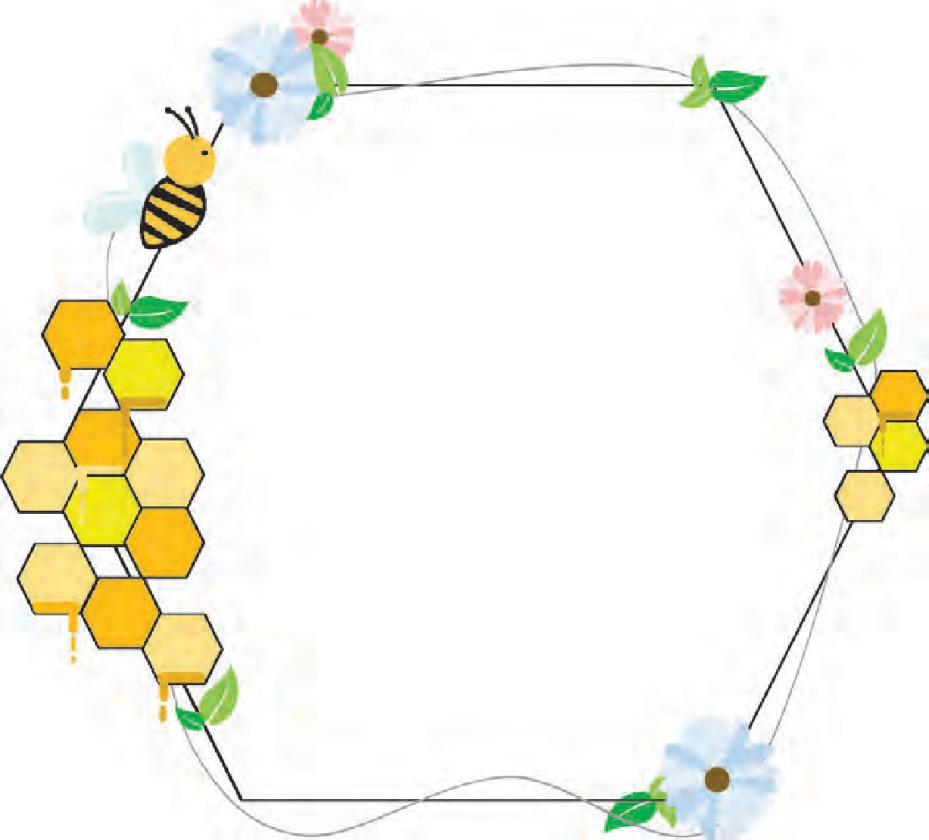

* 1. **How doth the little busy bee**

How doth the little busy bee Improve each shining hour, And gather honey all the day

From every opening flower.

How skilfully she builds her cell; How neat she spreads her wax,

And labors hard to store it well With the sweet food she makes.

*- Isaac Watts*

* * *

## A Parody

How doth the little crocodile Improve his shining tail;

And pour the waters of the Nile On every golden scale !

How cheerfully he seems to grin, How neatly spreads his claws, And welcomes little fishes in, With gently smiling jaws !

*- Lewis Carroll*

* * *

35

**ENGLISH WORKSHOP**



1. Write the meaning of :
   * doth • opening (in the context of the poem) • cell
2. A parody is playful, comic imitation of a writer’s style. A parody is like a verbal cartoon. Compare the original poem and its parody given on page 35 using the following points :

**How doth the little crocodile**

(parody)

...................................................

...................................................

...................................................

...................................................

...................................................

...................................................

....................................................

....................................................

**How doth the little busy bee**

(original)

Choice of subject (an animal)

...................................................

Number of lines and stanzas

...................................................

Same or similar constructions :

...................................................

Tone of the poem

...................................................

1. Answer the following questions and write in short, why the parody sounds funny.
2. What does the bee stand for ?
3. What does the crocodile stand for ?
4. Why does the bee work hour after hour ?
5. Why does the crocodile work ?
6. Is the bee a gentle creature ? Is the crocodile gentle ?
7. **Describe** a crocodile **in your own words**. Which of the words and phrases in the poem will you use in a realistic description ?

Put a tick mark against the ones you will use.

* + little  • shining tail  • golden scale  • cheerful
  + grin  • claws  • gently smiling  • jaws

1. Note that most of the times well-known works are parodied, because people can enjoy the parody better when they know the original. Try to find more examples of parodies in English or other languages.
2. What do you like better - the original poem or the parody ? Why ?

36

## Learn Yoga from Animals



 Where was yoga

perfected ?

 What does yoga involve ?

 What are the benefits of yoga ?

 What is

biomimicry ?

 In what way is yoga a form of biomimicry ?

* emulate : imitate
* vibrant : full of energy and life

37

Since the year 2015, the world has been celebrating June 21st as International Yoga Day. As most of us will know, yoga is a culture of physical, mental and spiritual discipline perfected in ancient India. Yoga as an ancient Indian discipline is a composite practice, involving the complete mind- body-soul complex that is a human being. Here, let us focus on yoga as an integrated system of physical exercises that help us to attain concentration, focus and also improve flexibility, balance, and strength.

From an ancient Indian discipline, let us move to a very contemporary area of research. Experts today are doing a wonderful job of drawing us into the world of biomimicry. In simple terms, bio means life and mimicry is to emulate. Basically biomimicry is the science of solving human problems with solutions already present in the natural world. From this point of view, yoga is also a form of biomimicry where in typical asanas or poses, we emulate mountains, trees, fish, cats, and so many more animals! This helps solve our problems brought on by day to day living – such as stiffness and back pain – and allows us to feel physically vibrant and mentally sharp.

Before we proceed further, here are a few basic precautions regarding yoga practice:

1. If you are a beginner, you should start practising yoga either in the presence of a yoga teacher or join yoga class so that you learn the basics and the do’s and don’ts of yoga.
2. Asanas should be practised in a clean, airy and well-lit room. The floor should be level. It is advisable to use a yoga mat. If it is not possible to practise indoors, you may practise on level ground outdoors.
3. The best time to practise is in the morning before breakfast or in the evening before dinner.

Some of the poses described below must be learnt from an instructor before you attempt to practise them on your own.

Let us look at a few well known animal poses in yoga:

* posture : the position in which you hold your body while sitting or standing
* tone : Here, it means firmness of muscle

**Steps :**

**Bhujangasana** is a beginner’s pose. Bhujanga in Sanskrit means a cobra. Bhujangasana is a pose that resembles the posture of a cobra with raised head. This asana helps you tone the muscles of the back and strengthens your spine. It also benefits the chest and shoulders.

**Demonstration:**

Read out the steps, and as you read out, indicate the expected action with appropriate gestures or actions.

Make sure that the viewers understand by asking questions such as ‘Is that clear?’

1. Lie face down. Relax all the muscles completely so that you are completely at ease.
2. Place your palms on the sides just below your shoulders.
3. Breathe in deeply as you slowly raise your head.
4. Then smoothly raise the upper part of your body.
5. Do not come up with a jerk. Let your movement be smooth and flowing.
6. Come up slowly so that you feel the movement of the spine vertebra by vertebra.
7. Curve the spine well.
8. The navel must keep touching the ground.

Hold the breath in this position to a count of twenty. Then come down slowly while you breathe out.

To start with you can repeat the process six times.

* navel : belly button
* assume : Here, it means ‘take’.

**Simhasana** or **Lion Pose** is a favourite with young people. In this asana, you assume the sitting position and facial expression of a lion. Although there may be a number of steps, this pose really requires very little effort.



38

**Steps :**



1. Sit with your legs folded under you so that your toes are pointing straight behind and you are sitting on your heels.
2. Keep your spine straight but as relaxed as possible.
3. Close your eyes and focus your attention on the centre of the forehead. In yoga, this point is often referred to as the third eye.
4. Closing your mouth, touch your palette ( roof of your mouth) with your tongue.
5. Take a deep breath through your nose while your tongue is still touching your palette.
6. Exhale in one strong move while sticking out your tongue and opening your jaws as much as possible. Also, your arms should be thrown out and stretched with your fingers splayed.
7. Roar at the top of your voice while exhaling. The roar should be with a ‘Haa’ sound and should not be a long drawn out one. Rather, it should be one strong explosion of breath that empties your lungs in the shortest time possible.
8. Hold this pose for between 20 and 30 seconds. Do not inhale immediately after this pose inhale,

after a few seconds.

Repeat 5 or 6 times.

This asana (posture) gets its name from the way you stick your tongue out as far as possible and the way you hold your fingers splayed out, resembling a roaring lion.

**Marjaryasana** is a very popular cat pose. This too, is a simple asana for beginners that stretches the muscles of the abdomen and the back.

Marjaryasana should be part of your morning yoga routine as

it will gently stretch your muscles and get rid of any bodyaches.

* + splayed : spread apart

**Role play:**

 Read the steps aloud as though you are instructing someone who is practising the pose

as per your instructions.

Add appropriate encouraging words and phrases such as ‘Thats right !’, ‘Slowly, now’.

39

**Pair-work :**

Give a demonstration of the ‘asana’, in a pair. One person reads out the steps, and the other person demonstrates the action. Rehearse the activity before you present it in the classroom.

**Steps :**

1. Start on your hands and knees so that your back is raised in a ‘tabletop’ position.
2. Make sure that your knees are positioned directly below your hips. Your wrists, elbows and shoulders should be in line and perpendicular to the floor.
3. Centre your head in a neutral position, with your eyes looking at the floor.
4. As you exhale, smoothly arch your spine upwards towards the ceiling, making sure to keep your shoulders and knees in position.
5. Release your head toward the floor, but don’t force your chin to your chest.

Inhale and come back to the neutral ‘tabletop’ position on your hands and knees.

To start with, you can repeat the process six times.

**Garudasana** or the **Eagle Pose** enhances your body’s ability to balance itself. It also strengthens the leg muscles and improves the flexibility of the joints by loosening the joint muscles.

**Steps :**

1. Stand straight on both feet. Raise the right leg and wrap it around the left leg
2. The right thigh should be over the left thigh and the right feet should touch the calf muscles from behind.
3. Similarly, wrap the right hand around the left hand.
4. Now place the palms together to resemble the beak of an eagle.
5. Try to maintain the balance and slowly bend the left leg and lower the body until right toes touch the ground.
6. Try to remain in this pose for long as you can maintain the balance.



40

After this asana, relax for some time before you repeat the process.

**Ustrasana** or **Camel Pose** strengthens the back; opens the shoulders, chest, and quadriceps; it also boosts mood and energy. This yoga posture adds flexibility and strength to the body and also helps in improving digestion.

**Steps :**

1. Kneel on the yoga mat and place your hands on the hips.
2. Your knees should be in line with the shoulders and the sole of your feet should be facing the ceiling.
3. As you inhale, draw in your tail-bone towards the pubis as if being pulled from the navel.
4. Simultaneously, arch your back and slide your palms over your feet till the arms are straight.
5. Do not strain or flex your neck but keep it in a neutral position.
6. Stay in this posture for a couple of breaths.
7. Breathe out and slowly come back to the initial pose. Withdraw your hands and bring them back to your hips as you straighten up.

Note: You may place a cushion below your knees to ease your way into the pose.

* quadriceps : the large muscle at the front of the thigh

**Demonstration:**

Form groups of 6-8. One person or a pair gives demonstration while others ask questions or make statements to present their difficulties. The demonstrator assures them that it is not necessary

to achieve everything the first time, they should take it easy.



**ENGLISH WORKSHOP**

1. Complete the following diagrams.

(A)

Benefits of yoga

|  |  |  |  |  |  |  |  |  |  |  |
| --- | --- | --- | --- | --- | --- | --- | --- | --- | --- | --- |
|  |  | | |  | | |  | | |  |
|  | |  |  | |  |  | |  |  | |

41

(B)

Precautions in Yoga Practice

|  |  |  |  |  |  |  |  |
| --- | --- | --- | --- | --- | --- | --- | --- |
|  |  | | |  | | |  |
|  | |  |  | |  |  | |

(C)

What is Yoga ?

|  |  |  |  |  |  |  |  |
| --- | --- | --- | --- | --- | --- | --- | --- |
|  |  | | |  | | |  |
| a culture of  ..........., ,  . discipline. | |  | composite practice involving  .................. | |  | integrated system of ................... | |

1. **Prepare charts** for each one of the asanas described in the passage. Use the following points : • Name (in English, in your mother tongue) • Meaning in English
   * General information • Steps and pictures • Benefits
2. List the names of body parts used in the passage.
3. List the adverbs/adverbial phrases used in the passage.
4. Language Study : **Conjunctions :** A conjunction is a word which joins words or clauses. Look at the following sentences.
5. Sahil **and** Rohan go to school together.
6. Sahil is drawing a picture **and**  Rahul is playing football. In sentence 1, the conjunction ‘and’ joins two words.

In sentence 2, the conjunction ‘and’ joins two clauses.

The following are some more examples of conjunction.

* Do you like cricket or football?
* Your parents will be happy if you study well.
* She has not come to school because she is ill.
* We played well, but we lost the match.
* Tell him that we are going to the playground.
* When you are at home, you should help your mother in her work.

**Interjections :** An interjection is a word that expresses a sudden feeling or emotion.

Interjections can express joy, grief, surprise, pain, approval etc.

Look at the following examples.

1. Hurrah! We have won the game. (Joy)
2. Ouch! That hurt. (Pain)
3. Wow! What a nice picture! (Approval)

42

## Chasing The Sea Monster



* frigate : small, speedy ship used in war
* unearthly : strange, not like those found on earth

**Think and answer :**

 What is the name of

the narrator ?

 What is the name of

the ship ?

 At what time is this event taking place ?

* luminous : bright, full of light
* fearsome : scary, frightening
* crew : people working on the ship

43

Jules Verne was a French writer. He is known as the ‘Father of Science Fiction’. He wrote about rockets, space travel and submarines when such things were unknown. In this passage, from his novel Twenty Thousand Leagues under the Sea, he describes how people on a ship think of the submarine as an animal and try to chase and hunt it.

Our frigate wanted to go back, but the unearthly animal came at us with a speed double our own. We gasped. More stunned than afraid, we stood mute and motionless.

The animal caught up with us, played with us. It made a full circle around the frigate and wrapped us in sheets of electricity that were like luminous dust. At any instant it could have dashed against our ship.

Meanwhile I was surprised to see that our warship was fleeing, not fighting. I commented on this to Commander Farragut. His face, ordinarily so emotionless, showed great astonishment.

“Professor Aronnax,” he answered me, “I don’t know what kind of fearsome creature I’m up against, and I don’t want my frigate running foolish risks in all this darkness. Besides, how should we attack this unknown creature, how should we defend ourselves against it? Let’s wait for daylight and then we’ll play a different role.”

The whole crew stayed on their feet all night long. No one even thought of sleeping. Unable to compete with the monster’s speed, our frigate, the Abraham Lincoln slowed down. For its part, the animal mimicked the frigate, simply rode with the waves, but did not leave the field of battle.

However, near midnight it disappeared, or to use a more appropriate expression, ‘it went out,’ like a huge

glowworm. Had it fled from us? We didn’t know and were filled with fear and hope at the same time. But at 12:53 a deafening hiss could be heard, resembling the sound made by a water spout expelled with tremendous intensity.



* cetaceans : marine animals like a whale
* lurking : hiding

 **Guess and write the meaning of :**

* astern to port

(Use the picture on page 48.)

* blunderbusses
* duck guns
* harpoon
* whaling gear : equipment used to hunt whales

44

By then Commander Farragut, Ned Land, and I were on the afterdeck, peering eagerly into the darkness.

“Tell me, Ned Land, isn’t that the noise cetaceans make when they spurt water from their blowholes?”

“The very noise, sir, but this one’s way louder. So there can be no mistake. There’s definitely a whale lurking in our waters.”

Near two o’clock in the morning, the core of light reappeared, five miles away from the Abraham Lincoln.

We stayed on the alert until daylight, getting ready for action. Whaling gear was set up along the railings. Our chief officer loaded the blunderbusses, which can launch harpoons as far as a mile, and long duck guns with exploding bullets that can wound and kill even the most powerful animals. Ned Land was content to sharpen his harpoon, a dreadful weapon in his hands.

At six o’clock day began to break, and with the dawn’s early light, the animal’s electric glow disappeared. At seven o’clock a very dense morning mist spread around us. Our best spyglasses were unable to pierce it. The outcome: disappointment and anger.

At eight o’clock the mist rolled away, and the horizon grew wider and clearer. Suddenly, Ned Land’s voice could be heard. “There’s the thing in question, astern to port!” the harpooner shouted. Every eye looked toward the point indicated.

There, a mile and a half from the frigate, a long blackish body emerged a metre above the waves. Quivering violently, its tail was creating a considerable current.

The crew were waiting impatiently for orders from their leader. The latter, after carefully observing the animal, ordered the engineer to sail full steam towards the animal.



* sail full steam : sail at full speed.

**Guess the meaning of :**

* cannoneer
* harpooner
* steal off : move away
* Mate : assistant

45

Three cheers greeted this order. The hour of battle had sounded.

A few moments later, the Abraham Lincoln headed straight for the animal. Unconcerned, the latter let us come nearer, it got up a little speed, and kept its distance.

This chase dragged on for about three-quarters of an hour without the frigate getting any closer to the sea animal. At this rate, it was obvious that we would never catch up with it.

The Abraham Lincoln gathered speed but so did the animal. This went on for the next hour. The Abraham Lincoln was now speeding so much that its masts trembled down to their blocks.

What a chase! No, I can’t describe the excitement that shook my very being. Ned Land stayed at his post, harpoon in hand. Several times the animal let us approach. Then, just as the harpooner was about to strike, the cetacean would steal off swiftly.

Commander Farragut then decided to use more direct methods.

“Bah!” he said. “So that animal is faster than the Abraham Lincoln. All right, Mate, man the gun in the bow!”

Our forecastle cannon was immediately loaded and levelled. The cannoneer fired a shot, but his shell passed some feet above the cetacean, which stayed half a mile off.

“Over to somebody with better aim!” the Commander shouted. “And $500.00 to the man who can pierce that infernal beast!”

Calm of eye, cool of feature, an old gray-bearded gunner - I can see him to this day - approached the cannon, put it in position, and took aim for a good while. There was a mighty explosion, mingled with cheers from the crew.



* armour : protective metal covering

 Guess what order the Commander must have given.

* profound : deep

46

The shell reached its target; it hit the animal, but bounced off its rounded surface and vanished into the sea two miles out.

“Oh drat!” said the old gunner in his anger. “That monster must be covered with six-inch armour plate!”

The hunt was on again. Hour after hour went by without the animal showing the least sign of weariness. However, it must be said that we, too, struggled on tirelessly.

At 10:50 in the evening, that electric light reappeared three miles away from the frigate, just as clear and intense as the night before.

The monster seemed motionless. Was it asleep perhaps, weary from its workday, just riding with the waves? This was our chance, and Commander Farragut decided to take full advantage of it. He gave his orders.

The frigate approached without making a sound, stopped two cable lengths from the animal. A profound silence reigned over the deck. We were not 100 feet from the blazing core of light, whose glow grew stronger and dazzled the eyes.



Just then, leaning over the forecastle railing, I saw Ned Land below me, brandishing his dreadful harpoon. Barely twenty feet separated him from the motionless animal.

All at once his arm shot forward and the harpoon was launched. I heard the weapon make a ringing sound as if it had hit some hard substance.

The electric light suddenly went out, and two enormous waterspouts crashed onto the deck of the frigate, racing like a torrent from one end of the ship to the other, toppling crewmen, breaking spare masts and yardarms from their lashings.

A hideous collision occurred, and thrown over the rail with no time to catch hold of it, I was hurled into the sea.

**Guess the meaning of :**

* enormous
* hideous

- *Adapted from* ‘*20,000 Leagues under*

*the Sea*’ *by Jules Verne*

* * *

**ENGLISH WORKSHOP**

1. From the passage, find all the words and phrases used to describe the ‘monster’.
2. Form groups of 4. Find all the references to time given in the passage. Then make a chart to show the events described in the passage along with the time when they occur. Example:
   * All night long : The crew stayed on their feet.
   * Near midnight :
   * At 12.53 :

(Use as many lines as you need.)

1. How long does the whole event described in this passage take ? **Work it out** by reading the passage.

**Read aloud the text on this page with proper intonation and emotion.**



47

1. 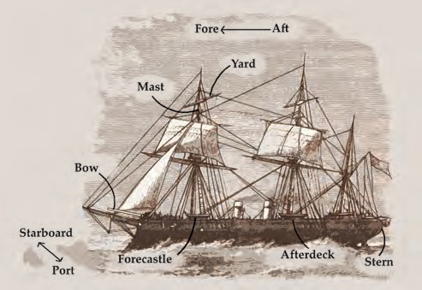**Observe** the picture and the labels carefully. Then match the words and the meanings given in the follwing table.

|  |  |
| --- | --- |
| **Words** | **Meaning** |
| 1. yard | (a) a floor, flat area built on a ship |
| 2. mast | (b) the forward part of the main body of a ship |
| 3. bow | (c) the forward part of a deck |
| 4. deck | (d) tall, upright pole on a ship |
| 5. forecastle | (e) a pole slung across a ship’s mast. A sail hangs from a yard. |
| 6. starboard | (f) the rearmost (back) part of a ship |
| 7. stern | (g) the part which is always at the front while the ship is sailing. |
| 8. afterdeck | (h) the right-hand side of a ship as one faces forward |
| 9. fore | (i) an open deck near the back |

1. Form groups of 4-5. Read the following sentences aloud. Using your imagination and with the help of group discussion, write other situations in which the sentences can be used.
   * The outcome: disappointment and anger. • The hour of battle had sounded
   * What a chase ! • This was our chance, ........
2. Find the different units of measurement mentioned in the passage and get more information about them from the internet.
3. Language Study : **Transitive and intransitive verbs :** We can classify verbs into two types – transitive and intransitive. Some verbs need on object / objects. When a verb has an object, it is a **transitive** verb. For example, ‘The boy kicked the football’. Here the verb ‘kick’ has ‘the football’ as its object. ‘Give’, ‘cook’, ‘buy’ are transitive verbs.

Some verbs do not need any objects. When a verb does not have an object, it is an **intransitive** verb. For example, ‘We laughed loudly’. The verb ‘laugh’ in this sentence does not have an object. ‘Laugh’, ‘walk’, ‘cry’ are intransitive verbs.

Some verbs can be transitive or intransitive. For example, ‘Birds fly’. (intransitive) ‘Children fly kites’. (transitive)

48

## Great Scientists

#### Great scientists are persevering and never deterred by difficulties.

Michael Faraday is regarded as one of the most distinguished scientists and inventors of modern times, and his work on electricity is still a subject of study, in the form of Faraday’s Laws. But few know his inspirational life story, which is all about courage and fighting against the odds.

Michael Faraday was born into a poverty- stricken family in a dirty London suburb. He suffered from a speech defect as a child. He would pronounce ‘rabbit’ as ‘wabbit’. He could not even say his own name and would call himself ‘Fawaday’. Other children laughed at him and teachers did not help him either. When he was twelve, his mother was forced to take him out of school, thus putting an end to his formal education.

At thirteen, however, he started working with a bookbinder, binding hundreds of book during the day and staying up all night to read them. Reading thus became his obsession. One day he came across a book on electricity which had been sent to his master for binding. He started reading it and was completely hooked. That was his first introduction to the subject of electricity, which soon became a lifelong fascination.

Faraday was still poor at twenty-one. Once, a friend gave him a free ticket to a public lecture and demonstration by the renowned chemist Humphry Davy at London’s Royal Institution. Davy’s work on chemicals and electrical lighting was the subject of conversation among the scientists

 Before you read further, guess what the passage is about.

**Listen, read and answer :**

 What were the odds against Faraday in his childhood ?

**What is meaning of :**

* Reading became his obsession
* Electricity became a lifelong fascination.

**Think and answer :**

 Why do you think Faraday’s friend give him a free ticket to Davy’s programme?

49



of that age. Seventy years later, across the Atlantic Ocean in the USA, the same work enabled Thomas Edison to produce the first consistent light bulb.



**Find the answer on this page :**

 What was the subject of Davy’s lecture?

 What actions and

thought of Faraday show that he was inspired by Davy?

**Guess the meaning of :**

* mentor.

 Why did Davy

choose Faraday as his secretary ?

 Was Davy fair in his treatment of Faraday ?

 How did Faraday respond to that treatment ?

50

That day in 1812 Faraday was spellbound by Davy’s lecture. He kept taking notes about the ‘mysterious force of electric fluid’. He was so engrossed in the lecture that he forgot to applaud with the rest of the crowd. When he went back, his notes were so comprehensive that he bound them into a book, meaning to gift it to Davy some day. Faraday decided that day that he didn’t just want to sell books, he wanted to be a great scientist

- good enough to write his *own* books. Davy became his role model. But there was a problem. He did not have the social status, money or the education to pursue science. Faraday thought it would be wonderful if Davy became his mentor, but Davy did not agree initially. Faraday was not dejected; he just kept trying.

Destiny had a strange plan in store for him. A few years later, a chemical explosion happened inside Davy’s lab and he was temporarily blinded. He now needed an assistant with an excellent memory to help him. He was reminded of Faraday and decided to hire him as his secretary. Davy never believed Faraday could do anything in the field of science going by his social status and education. He therefore dismissed Faraday’s aspirations and advised him to stick to bookbinding. But Faraday was relentless. He worked day and night and learnt as much as he could about Davy’s experiments. Soon Faraday became indispensable to Davy, and was promoted to his lab assistant. This was his first step towards a scientific career. Though much of his job now was cleaning labs, at least he got to see some of Davy’s leading experiments.

Even then Davy did not have much hope for Faraday. Then Faraday got another chance to prove

himself. One day Davy tried to re-create a famous electromagnetism experiment with fellow chemist William Wollaston, exploring why when an electric current is applied to a wire, it causes that wire to behave like a magnet. Obviously, the forces were connected but nobody had figured out how to make it happen continuously. Davy believed that if he could find out why it happened and controlled it, there could be many practical applications of the force. But he was unable to figure it out and was frustrated. He then teased Faraday, asking him to try his hand at it after he was done cleaning the lab.

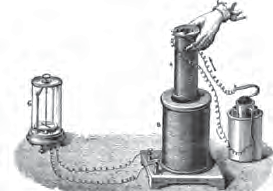

 What happens

when an electric current is applied to a wire ?

**Give one example each to show that**

 Faraday was a good pupil.

 Davy was not a good mentor.

An induction motor is a commonly used eletrical machine.

 What examples of its use are given here?

51

Within a few days, Faraday solved the problem. In fact, he went further and the result was the first induction motor, which converted electrical current into continuous mechanical motion.

The induction motor spurred a revolution. Fans, air conditioning, sewing machines, photographs, power tools, cars and even trains and aeroplane engines grew out of this simple device which was born out of mockery directed at Faraday.

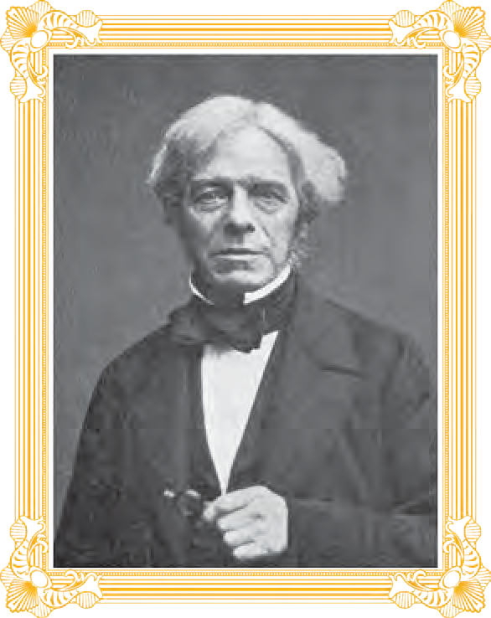Faraday became a celebrity scientist overnight. Nobody now cared about his social status or education; this young man had just created a revolution. One would think, as a teacher Davy was happy at his pupil’s achievement. But in reality he was jealous. People

started telling Davy that of all his discoveries, the best was Faraday himself; this made him even more jealous. An angry Davy gave Faraday an impossible task to keep him out of his way. He handed him a piece of Bavarian glass, which was used in the lenses in telescopes and microscopes, and asked him to reverse engineer it. Bavarian

glass was manufactured by a secret complicated process and Davy knew that with the equipment available in the lab Faraday would never be able to accomplish the task. This piece of glass became a significant thing in his life.



**Guess the meaning of :**

* reverse engineer it.

‘In order to succeed, your desire for success should be greater than your fear of failure’.

*- Michael Faraday*

 Write the idea

behind an eletrical generator.

52

Faraday had a never - give - up attitude and he respected Davy. So he accepted the assignment, despite knowing that it would be very difficult. He toiled for four years, with no help from Davy, and, as expected, failed. Faraday never learned the secret, and this remained his first failure as a scientist. To remind himself of these difficult times, he kept a single glass brick on his shelf as a souvenir. This would inspire him during difficult times.

In 1829, Davy died and Faraday succeeded him as head of the laboratory. He was free to pursue whatever he liked, and he made another revolutionary discovery. He noticed that if he moved a magnet, it could produce electrical current; thus he could now convert motion into electricity. This is how the electrical generator was born, something still used today to generate all kinds of power, like dynamos and other devices.

Faraday was now a legend. In 1840, he developed memory loss, which continued for the rest of his life. But the disease did not stop him. He persevered, starting a complicated experiment to prove that light was closely related to electricity and magnetism - a novel thought in those times.

Remember that piece of Bavarian glass Faraday had kept on his shelf ? He was determined to convert the reminder of his first major failure to an instrument of great success. He used the same glass now to show that in the presence of a magnet, light could be isolated into a single wave rather than spreading out randomly in all directions, a concept called polarization.

He then took the age - old experiment of sprinkling iron filings on a sheet of paper near a magnet, making circular patterns. He went on to prove that these patterns were not a property of the iron filings; in fact they were due to the invisible magnetic fields that filled the empty space around the magnet and hence disturbed the filings. This is where his lack of formal education went against him. Faraday did not know much about advanced mathematics, so he just copied the iron filing patterns with his hand. He was unable to explain them in the form of mathematical equations. He made hundreds of such drawings but without equations, they were not accepted.

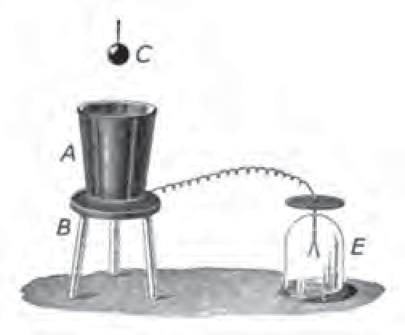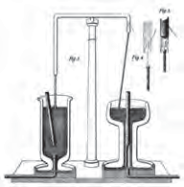

 Try out the

experiment of the iron filings and the magnet.

 Why were

Faraday’s drawing not accepted ?

 Does it mean

they were wrong ?

53

Fortune favoured the brave Faraday once again when he met James Maxwell, a wealthy, educated physicist well versed in mathematics. He was willing to work with Faraday. It was Maxwell who translated Faraday’s idea into a set of equations that are now called Maxwell’s equations. Their combined work has helped us in many ways. Electronics and communication system today are designed around their discoveries. Some day, we might even be able to communicate with aliens across different galaxies using the products of these discoveries.

Faraday’s life started with difficulties, but as a great scientist he met each difficulty with perseverance and conviction. He was given impossible tasks, which he undertook as challenges and opportunities. He epitomizes what the Walt Disney character Pinocchio said :

‘When you wish upon a star

It does not matter who you are’.

- *From the Introduction to ‘Reignited’ by A.P.J. Abdul Kalam and Srijan Pal Singh*

* * *

**ENGLISH WORKSHOP**



1. **Write what is implied** in the following sentences.
2. But few know his inspirational life story, which is all about courage and fighting against the odds.

(What does it tell you about Faraday’s life ?)

1. Even then Davy did not have much hope for Faraday. (What do the words ‘even then’ suggest ?)
2. People started telling Davy that of all his discoveries, the best was Faraday himself.

(What does it suggest about Davy’s work ?)

1. Break the passage into convenient smaller sections. Give **sub-headings or titles** to each section.
2. List the different gadgets and instruments mentioned in the passage. Find more information about them (at least 3), using the internet.
3. Find out more about the following scientists with the help of the internet.
   1. Michael Faraday
   2. Humphry Davy
   3. Thomos Edison
   4. James Maxwell
4. Language Study : **Subject and predicate :** A word or a phrase in a sentence that shows who or what does the action, is the **subject**. In the following sentences, the underlined part is the subject.

The baby is laughing.

The glass fell from the table.

The **predicate** is the part of a sentence that tells us something about the subject. The underlined parts of the following sentences show the predicates in them.

The baby is laughing.

The glass fell from the table.

  

54

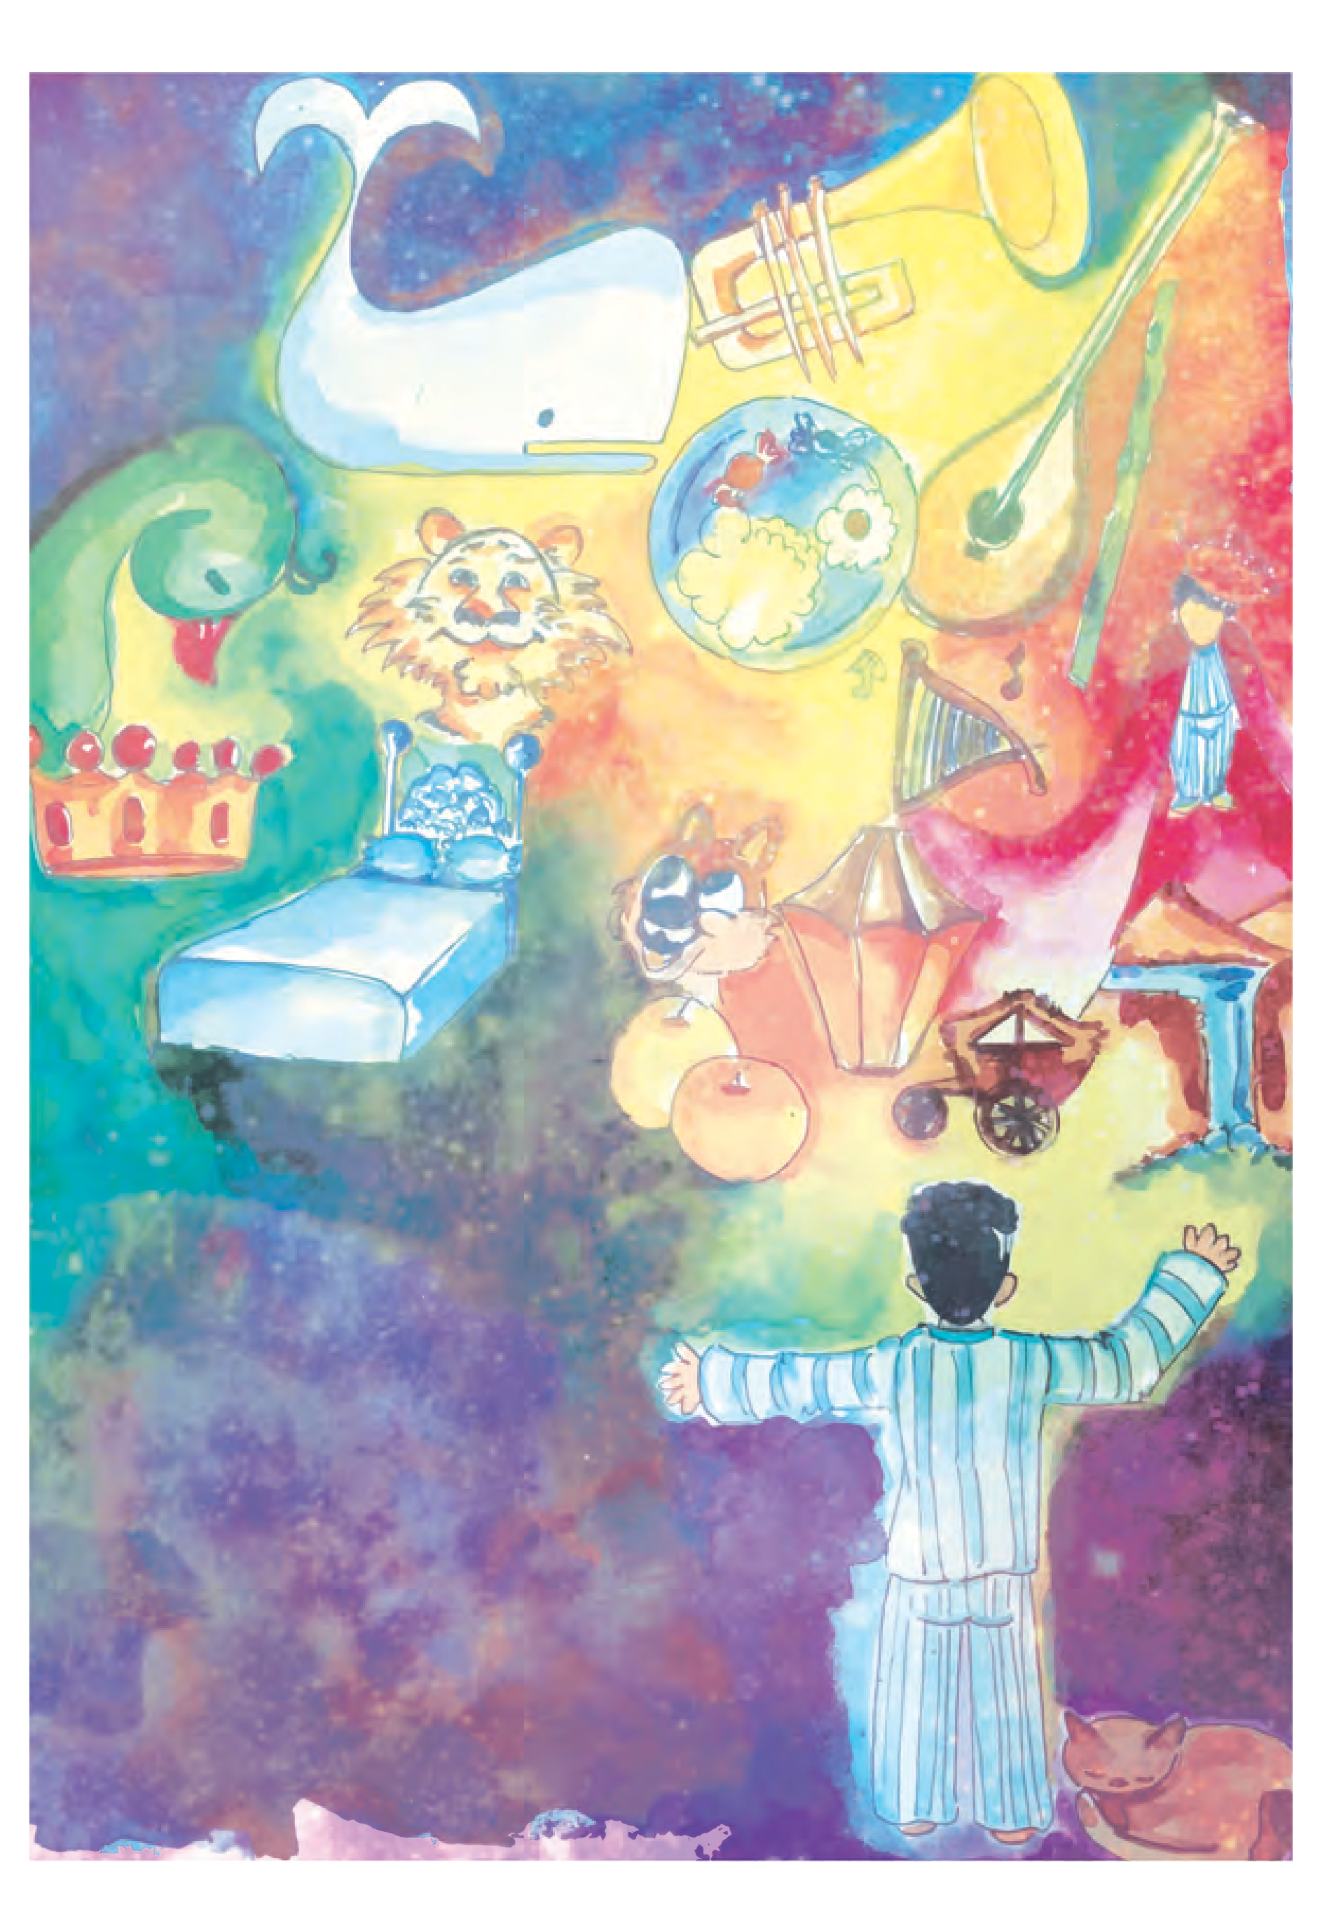

* 1. **Tartary**

If I were Lord of Tartary, Myself and me alone,

My bed should be of ivory, Of beaten gold my throne;

55

And in my court should peacocks flau And in my forests tigers haunt,

nt,

And in my pools great fishes slant Their fins athwart the sun.

If I were Lord of Tartary, Trumpeters every day

To every meal would summon me, And in my courtyard bray;

And in the evening lamps would shine, Yellow as honey, red as wine,

While harp, and flute, and mandoline, Made music sweet and gay.

If I were Lord of Tartary,

I’d wear a robe of beads,

White, and gold, and green they’d be - And clustered thick as seeds;

And ere should wane the morning-star, I’d don my robe and scimitar,

And zebras seven should draw my car

Through Tartary’s dark glades.

Lord of the fruits of Tartary, Her rivers silver-pale!

Lord of the hills of Tartary, Glen, thicket, wood, and dale!

Her flashing stars, her scented breeze, Her trembling lake like foamless seas, Her bird-delighting citron-trees

In every purple vale!

*- Walter de la Mare*

**ENGLISH WORKSHOP**



1. Find the words that mean the following from the first stanza.
   * Gold hammered into a flat, thin shape :
   * show off proudly :
   * tilt, move at an angle :
   * across, especially in a slanting direction :

56

1. Find the names of the exotic musical instruments and animals mentioned in the poem.
2. In the last stanza, there are three four-letter words that refer to a beautiful valley.

They are : • • •

1. From the poem, find three lines that use comparisons.

• • •

1. Colour, sound and images from nature add to the beauty of a poem : ‘Tartary’ is a perfect example of the above. Pick out lines that contain -
   * Colour
   * Sound
   * Images from nature
2. Complete the following phrases with the help of the poem.
   * music • rivers • breeze
   * lake • citron-trees
3. Write about the daily routine of the ‘Lord of Tartary’ in 8-10 lines.
4. Using your imagination, write about a beautiful region - its land forms, water bodies, flora and fauna, night sky, people, etc.
5. Language Study : **Consonance : Consonance** is repetition of one or more consonant sounds especially at the end of words. Consonance is usually pleasant to the ear.

Examples : • Pitter-patter, pitter-patter

* + Rivers silver-pale
  + The lint was sent with the tent.
  + All’s well that ends well.
* Find at least two examples of consonance from poems that you study in this book.

  

57

* festive : joyous

## Compere a Programme

#### Getting ready for the programme

Good Morning friends ! It is a pleasure for me to welcome you all to this festive occasion. Please take your seats. May I request you to keep your mobiles switched off or on silent mode ? Let us ring in to the merry mood of youthful creative expressions and forget our preoccupations and ringtones for the time being.

 Why does the compère request the audience to switch off their mobile phones ?

 Why does she request them to be seated ?

 At the beginning of the programme, who does the compère address by name ?

#### Arrival of the dignitaries

I am happy to announce that the dignitaries have arrived. I request you all to be seated.

I request our Head Girl Miss Shubhada Murarka to escort the dignitaries to the dais.

#### Commencement of the programme

Honourable Chief Guest of today’s function and an artist of great renown Shri. Charudatta Diwan, President of Balanand Education Society, Shri. Avadhoot Pathak, Our Principal Dr Ajinkya Parakhi, Vice Principal Dr Shaila Singh, all our invited guests, parents, teachers and my dear friends,

on behalf of Balanand Vidyalaya I extend a hearty welcome to you all.

We have gathered here for the inauguration of our School Art Festival.



58

#### Lighting the lamp



 Do you have a

school song ? What does it tell you ?

**Guess the meaning of :**

*Atithi Devo Bhava!*

 What do we learn about

Shri. Charudatta Diwan from the compère’s

speech?

**Think and answer:**

 Who does the compère thank?

59

Let us begin this auspicious occasion with something symbolic of knowledge and learning. And for this I would like to request all the honourable members on the dais to kindly light the traditional lamp and offer prayers ...

Friends, look at the amazing quality of this lamp; when lit, not only does it carry the tremendous potential to break the darkness of the night but also leaves way for a thousand other lamps to be lit from its flames. Likened to the lamp is knowledge. Knowledge, too, spreads light. It neither divides nor subtracts. It only adds and multiplies.

Miss Anagha Bhatia of Std VII and her group will now sing the School Song.



**Welcome and introduction of the guests**

*Atithi Devo Bhava !*

Our Indian culture regards guests as gods. Let us welcome and honour our distinguished guests.

It is indeed our proud privilege to have amidst us a very eminent personality from the field of Art and Culture, renowned Artist, a Painter of International Repute, and proud recipient of many prestigious awards, President of Kala Ranjan Academy Shri. Charudatta Diwan. I would request our Principal to welcome him by offering a token of our love and appreciation - books - Two Volumes of Cherished Lives of Great Artists. We are offering books because flowers might perish but books can stay forever ...

Thank you, Sir.

I would now request the Convener of this Art Festival, our Art teacher, respected Ms Shilpa Sanghani to welcome the beacon of our institution,

the President of Balanand Academy, Mr Avadhoot Pathak ...



Who are they ?

* Mr Avadhoot Pathak
* Ms Shubhada Murarka
* Mr Ajinkya Parakhi

 Describe the book

that is released.

 Why does the compère thank the Chief Guest ?

 Who is taking

part in the Taal Kacheri ?

 Guess / Find the meaning of Taal Kacheri.

60

I would now request our School Captain and Cultural in-charge Ms Shubhada Murarka to welcome our ever inspiring dynamic Principal Dr Ajinkya Parakhi Sir ...

Our enthusiastic Vice-Principal will be welcomed by Ms Anagha Bhatia ...

Thank you, Dear Anagha.



#### Introductory speech

To appraise you about the Art Festival, I request the Principal, Respected Dr Ajinkya Parakhi to deliver his introductory speech ...

#### Book release

Friends, we have prepared here a volume comprising photographs of all the beautiful and unique pieces of art which are displayed today in the auditorium. They are the artistic and skilful contributions from our students. I request the Chief Guest to release this special book on this occasion and formally inaugurate the art festival ...

Thank you, Sir.

I know this has aroused curiosity in you to see the exhibition. After this programme you can take that pleasure.

#### Cultural programme

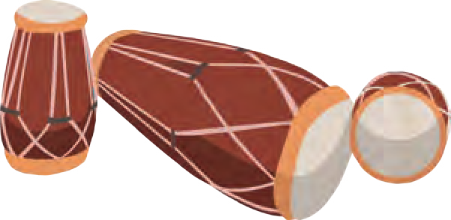I know you all are eagerly waiting to listen to the gems of music from

our school. We now invite this talented band of musicians to display their talent. We proudly present the **Taal Kacheri**.

Sahil of Std X A will give a vocal rendition and the same piece will be demonstrated on different instruments. Let’s enjoy the Taal kacheri.

Varsha on Mridangam, Vivek on Dholak, Zubin on Tabla and Govind on Ghatam ...

Let us have a big round of applause for the excellent demonstration.

Different States display their unique identity through their respective culture. Std VII C will now give a beautiful presentation of the famous **Koli Dance** from Maharashtra ...

What a wonderful presentation !

Now a **light comedy** play will be presented by std IX C. I would like to request Std IX artists to perform their play - **The Boy Comes Home** by A.A.Milne ...

That was indeed a fantastic performance !

#### Prize distribution

You are all eagerly waiting for the prize distribution. There are butterflies in your stomachs. You will soon be relieved of your anxiety. Everyone is unique in his or her potential. All are talented, yes, but some do perform better and their talent needs to be appreciated. I would now invite the Chief Guest to declare the prize winners and give away the prizes for the different categories of Art ... Thank you, Sir.

**Address by the Chief Guest**

I would now request our illustrious Chief Guest to address the audience ...

Thank you, Sir, your speech has given us wonderful insights on various aspects of Art and Culture. We are immensely grateful to you for your invaluable words of enlightenment.

 How is this vocal rendition different from music?

 Does the compère say the following at the beginning of the programme or after

it has ended ?

* What a wonderful

presentation.

* + That was indeed

a fantastic performance !

 What is meant by ‘butterflies in your stomach’?

61



#### Vote of thanks

Before we draw the curtain I take the opportunity to thank all those who have lent a helping hand to make this Art Festival meaningful and for the formal vote of thanks I invite the convener of this programme, our Art teacher Ms Shilpa Sanghani.

* * *



**ENGLISH WORKSHOP**

1. The items in the programme below have got mixed up. Rearrange them in the proper order. Just add the number in the left hand column.

|  |  |
| --- | --- |
| **Balanand Vidyalaya Art Festival Programme** | |
| ( )  ( )  ( )  ( )  ( )  ( )  ( )  ( )  ( )  ( ) | Koli Dance Igniting the Lamp  Chief Guest Speaks  Appraisal of the Art Festival Dignitaries Arrive  Recital of ‘Taal kacheri’  Welcome and Introduction of Guests Prize Distribution  The Boy Comes Home - A skit by Std IX Vote of Thanks |

1. Form groups of 5-8. This passage tells us only what the compère says. Try to **visualise and write** what the other people on the dais must have said in their speeches (Write only the main points.)
   * The School Principal
   * The Chief Guest
   * The Art teacher who offered vote of thanks

62

1. Choose the appropriate phrase to insert in the gaps, to make the sentences meaningful. Use the appropriate form of the verb.

(1) to appraise (2) to be relieved of (3) to draw the curtain

(4) to escort (5) to be likened to (6) to have butterflies in ones stomach

1. Before we ....................., let us stand in attention for the National Anthem.
2. I ..................... just as I was to receive my Report Card.
3. After I took the medicine, I ..................... ..................... the pain.
4. Before we do the experiment in the Laboratory, let me you

all about it.

1. The minister .......................................... his personal body-guards.
2. Sorrowful times are darkness.
3. Prepare a formal invitation card for the Art Festival.
4. **Prepare a news report** in brief on this Art Festival.
5. **Chalk out detailed programmes** for the following occasions.
   * The Teacher’s Day programme in your school.
   * An exhibition of science projects arranged in your classroom.
   * A wedding anniversary/birthday celebration for your grandparents that you have arranged with your family.
6. Language Study : **Object : Direct and indirect -** An object is a word, phrase or clause that shows the person, thing etc. affected by the action of the verb. The underlined words or phrases in the following sentences are objects.
7. Mother drives a scooter.
8. He gave me a pen.

There are two types of object : direct and indirect. The direct object is directly affected by the action. For example, in sentence 2 above, ‘a pen’ is direct object. An indirect object refers to the person or a thing to whom/for whom the action is done. In sentence 2 above, ‘me’ is an indirect object.

  

63

 What dangers were likely

to befall the young crow ?

 Who were the other members of the author’s family living in the same house ?

 Did the author’s Grandfather like animals ? How do we know that ?

Give two examples from this page to support your answer.

 What is implied in ‘He took over the administration of the house ?

## A Crow in the House

The young crow had fallen from its nest and was fluttering about on the road, in danger of being crushed by a cart or a tonga, or seized by a cat, when I picked it up and brought it home. It was in a sorry condition, beak gaping and head dropping, and we did not expect it to live. But Grandfather and I did our best to bring it round. We fed it by prizing its beak gently open with a pencil, pushing in a little bread and milk, and then removing the pencil to allow it to swallow. We varied this diet with occasional doses of Grandmother’s home-made plum wine, and as a result, the young crow was soon on the road to recovery.

He was offered his freedom but he did not take it. Instead he made himself at home in the house. Grandmother, Aunt Mabel, and even some of Grandfather’s pets objected; but there was no way of getting rid of the bird. He took over the administration of the house.

We were not sure that he was male, but we called him Caesar.

Before long, Caesar was joining us at meal times, besides finding his own grubs or beetles in the garden. He danced about on the dining table and gave us no peace until he had been given his

small bowl of meat and soup and vegetables. He was always restless, fidgeting about, investigating things. He would hop across a table to empty a match-box of its content, or rip the daily paper to shreds, or overturn a vase of flowers, or tug at the tail of one of the dogs.

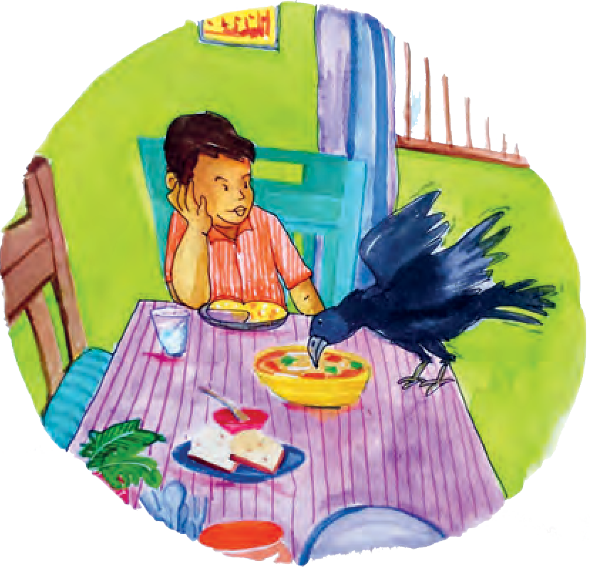

64

‘That crow will be the ruin of us !’ grumbled Grandmother, picking marigolds off the carpet. ‘Can’t you keep him in a cage ?’



* carrion crows : crows feeding on dead or decaying flesh (and other garbage)

 Guess how

Caesar learnt to say ‘Hello,

hello’ .

 What is meant

by ‘Aunt Mabel never was a success with the pets’ ?

Can you think of the reasons why it was so ?

* engaging : Here, it means charming or attractive

65

We did try keeping Caesar in cage, but he was so angry, and objected with such fierce cawing and flapping, that it was better for our nerves and peace of mind to give him the run of the house. He did not show any inclination to join the other crows in the banyan tree. Grandfather said this was because he was really a jungle crow - a raven of sorts - and probably felt a little contemptuous of very ordinary carrion crows. But it seemed to me that Caesar, having grown used to living with humans on equal terms, had become snobbish and did not wish to mix with his own kind. He would even squabble with Harold the Hornbill. Perching on top of Harold’s cage, he would peck at the big bird’s feet, whereupon Harold would swear and scold and try to catch Caesar through the bars.

In time, Caesar learnt to talk a little - as ravens sometimes do - in a cracked, throaty voice. He would sit for hours outside the window, banging on the glass with his beak and calling, ‘Hello, hello’. He seemed to recognise the click of the gate when I came home from school, and would come to the door with a hop, skip and jump, saying, ‘Hello, hello !’ I had also taught him to sit on my arm and say ‘Kiss, kiss’, while he placed his head gently against my mouth.

On one of Aunt Mabel’s visits, Caesar alighted on her arm and cackled, “Kiss, Kiss !” Aunt Mable was delighted - and possibly flattered - and leant forward for a kiss. But Caesar’s attention shifted to my aunt’s gleaming spectacles, and thrusting at them with his beak, he knocked them off. Aunt Mabel never was a success with the pets.

Pet or pest ? Grandmother insisted that Caesar was a pest, in spite of his engaging habits. If he

* took to visiting

: visited regularly as a matter of habit.

 What is implied in the following sentence :

* Most of the neighbours were represented in our house by a toothbrush.

 What actions of the author show that he loved Caesar ?

had restricted his activities to our own house, it would not have been so bad; but he took to visiting

neighbouring houses and stealing pens and pencils, hair-ribbons, combs, keys, shuttlecocks, tooth- brushes and false teeth. He was especially fond of toothbrushes, and made a collection of them on top of the cupboard in my room. Most of the neighbours were represented in our house by a toothbrush. Toothbrush

sales went up that year. So did Grandmother’s

blood-pressure.

Caesar spied on children going into the bania’s shop, and often managed to snatch sweets from them as they came out. Clothes pegs fascinated him. Neighbours would return from the bazar to find their washing lying in the mud, and no sign of the pegs. These, too, found their way to the top of my cupboard.

It was Caesar’s gardening activities that finally led to disaster. He was helping himself to our neighbour’s beans when a stick was flung at him, breaking his leg. I carried the unfortunate bird home, and Grandfather and I washed and bandaged his leg as best we could. But it would not mend. Caesar hung his head and no longer talked. He grew weaker day by day, refusing to eat. An occasional sip of Grandmother’s homemade wine was all that kept him going.

One morning I found him dead on the sofa, his legs stiff in the air. Poor Caesar ! His anti-social habits had led to his early end.

I dug a shallow grave in the garden, and buried him there, along with all the toothbrushes and clothes pegs he had taken so much trouble to

collect.

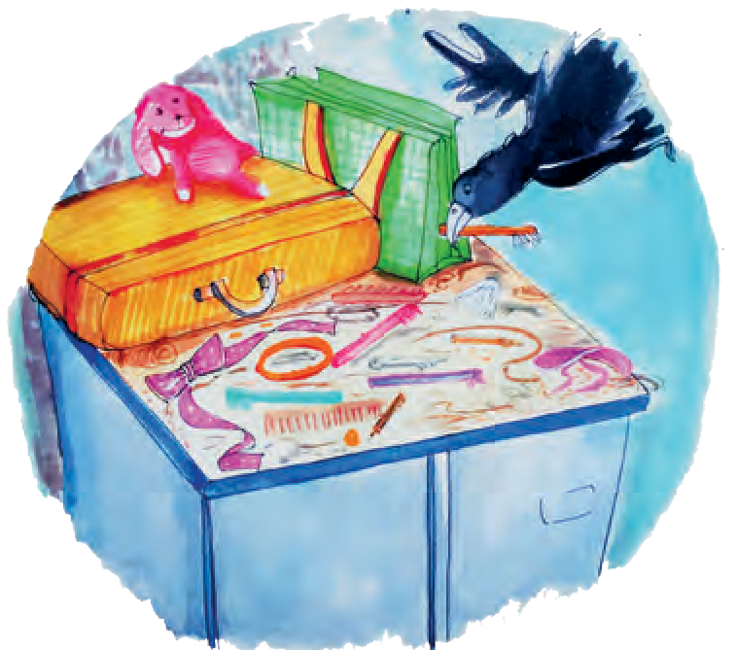

66

*- Ruskin Bond*

(*From ‘Grandfather’s Private Zoo’* )

**ENGLISH WORKSHOP**



1. (A) **Find antonyms** for the following from the story.
   * motionless x • captivity x • frequent x
   * dull x • gentle x • co-operated x
   * deep x • humble x

(B) Now try to **find out synonyms** (words that mean the same) for the following : (You may use a dictionary / theasures)

* + disapproved : • bits/pieces : • achievement :
  + attracted : • nuisance : • mishap :
  + controlled : • rebuke :

1. Using your imagination, write how the other pets in the house could have objected to Caesar living in their house.
2. **Prepare a table** to show ‘Caesar’s Pranks’ at home and outside.
3. Relate the life-story of Caesar, rearranging the facts in a proper sequence in the form of a **flow chart** :
   * Caesar begins to upset things at home • Neighbour flings a stick at Caesar
   * Young crow is saved by the narrator • Caesar begins to trouble neighbours
   * The crow is named Caesar • Caesar passes away
   * Caesar objects to being caged.
4. Rewrite in your own words (a) One event from the story (b) One of the Caesar’s traits that makes you laugh.
5. **Hold a debate on** - ‘Pets or Pests ?’
6. Do you have pet animals ? Write an interesting story about your own or your friends’ pet.
7. Language Study : **Complement :** There are two types of complement : subject complement and object complement. **Subject complement** is a word or a phrase used after a verb that describes the subject. The underlined words and phrases in the following sentences are subject complements.
8. I am hungry. 2. My sister became a teacher.

The word ‘hungry’ and the phrase ‘a teacher’ describe the subjects of the verbs. Therefore, they are subject complements.

An **object complement** comes after the object of a verb and gives us information about the object. The underlined words and phrases in the following sentences are object complements.

3. The class made her the monitor. 4. The teacher found my answer correct.

The phrase ‘the monitor’ gives us information about the object ‘her’. The word ‘correct’ gives us information about the object ‘my answer’.

67

## The Brook

I come from haunts of coot and hern, I make a sudden sally

And sparkle out among the fern, To bicker down a valley.

By thirty hills I hurry down, Or slip between the ridges,

By twenty thorpes, a little town, An half a hundred bridges.

Till last by Philip’s farm I flow To join the brimming river,

For men may come and men may go, But I go on for ever.

I chatter over stony ways, In little sharps and trebles, I bubble into eddying bays, I babble on the pebbles.

With many a curve my banks I fret By many a field and fallow, And many a fairy foreland set

With willow-weed and mallow.

I chatter, chatter, as I flow To join the brimming river,

For men may come and men may go, But I go on for ever.

68

I wind about, and in and out, With here a blossom sailing, And here and there a lusty trout, And here and there a grayling,

And here and there a foamy flake Upon me, as I travel

With many a silvery waterbreak Above the golden gravel,

And draw them all along, and flow To join the brimming river

For men may come and men may go, But I go on for ever.

I slip, I slide, I gloom, I glance, Among my skimming swallows; I make the netted sunbeam dance Against my sandy shallows.

I murmur under moon and stars In brambly wildernesses;

I linger by my shingly bars; I loiter round my cresses;

And out again I curve and flow To join the brimming river,

For men may come and men may go, But I go on for ever.

*- From* ‘*The Brook*’ *by Alfred Lord Tennyson*

haunt : a place that one visits often, where one spends a lot of time.

coot and hern : Coot and hern are both water birds. Hern stands for the common European heron.

sally : a quick journey bicker : run noisily

thorpe : old English word for a village sharps and trebles : musical sounds

fret : wear out, gnaw

fairy foreland : Here, it refers to a scenic place that looks like an entrace to fairyland.

mallow : a plant with purple flowers grayling : a freshwater fish with a long fin skimming swallows : swallows that touch the brook lightly and quickly as they fly over it.

69

shingly : full of shingles, that is, small rounded pebbles or stones

bar : barrier, obstacle cress : small plant



**ENGLISH WORKSHOP**

1. **Read the poem aloud** with proper pace and rhythm.

1. Find the meaning of the following words or phrases :
   * ridges • brimming • eddying • babble • fallow • trout • netted
2. Answer the following :
3. Who is the speaker in this poem ?
4. Which lines are repeated in the poem ? What do they mean ?
5. Where does the brook join the river ?
6. Mention the various places that the brook flows past.
7. Often the brook speaks of itself as if it is human. For example, ‘I bicker down a valley.’

Find two other examples of the human activities of the brook.

1. Spot and write any three alliterative phrases or sentences from the poem. (Alliterative phrases / sentences are those in which the same sound is repeated.)
2. List the prepositions you find in this poem.
3. List the phrases which have the expression ‘many a ’.
4. The poet uses words to create pictures or ‘images’ in the reader’s mind. For example, ‘ And sparkle out among the fern.’

Write down other lines that create images or pictures in your mind. (Any 3)

1. **Write a short autobiography** of a brook. (20 to 30 lines)
2. Which other things in nature can say - ‘For men may come and men may go,

But I go on for ever.’

1. Use the internet, your school library or other sources for the following activities.
2. Try to find other nature poems.
3. Draw or collect landscapes that can be used as illustrations for this poem.

  

70

# News Analysis

(a)

**CLOSED SHOES NOT ALLOWED IN EXAMINATION HALLS**

**Bengaluru :** Shivam Institute of Innovative Technology, Bengaluru has recently issued a list of DOs and DON’Ts for candidates taking the Entrance Test to the prestigious institute this year.

The candidates will not be allowed to enter the examination hall

wearing closed shoes, boots, even socks. Other items which will not be allowed inside include mobile phones, microphones, earplugs, calculators and other electronic gadgets, pouches, printed or blank papers and even pens. The pens will be provided in the hall by the invigilators.

1. What is the meaning of ‘issued’, ‘candidates’ and ‘invigilators’ ?
2. Who is conducting the test ?
3. Discuss the following in groups of four or five :
   1. Why is closed footwear (shoes, socks) not allowed in the examination hall ?
   2. Why has the institute not allowed electronic gadgets in the hall ?
   3. What other measures can be taken to prevent copying ?
4. Why is this news published in newspapers ?

(b)

## RITIKA TAKES A BREAK FROM ACTING

**Mumbai, *Sept.9,* :** Famous actress Ritika, who is believed to be the most highly paid star in Bollywood, is all set to break the hearts of her fans. In an informal chat with journalists, she revealed that she will not sign any

more films, after completing the big - budget movie ‘Ant’ next month. She refused to give any reasons for her decision. However, sources close to her reveal that now she wants to make a career in politics.





1. Guess the meaning of ‘most highly paid’, ‘revealed’, ‘sign films’.
2. What words are used for the following in the news item :
   1. Film Industry (b) Something on which a lot of money is spent.
3. Guess why ‘Ant’ is a big - budget movie.
4. Can you think of other reasons for Ritika’s decision ?
5. What will be Ritika’s reaction to this news ?

71

**MOST DANGEROUS TIME IN HISTORY**

**London :** The famous physics

professor Stephen Hawking has warned that mankind is facing the most dangerous time in

its history today. He said that the world today is facing huge challenges like climate change, overpopulation, epidemic diseases. ‘We have the technology to destroy the planet on which we live and have not yet developed the ability to escape it. Perhaps in a few hundred years from now, we will have built colonies amid the stars, but right now, we have only one planet and we need to work together to protect it.’ Hawking wrote recently in the *Guardian* newspaper.

(c)

1. Guess the meaning of ‘mankind’.

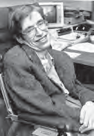

1. Which words or phrases in the news refer to the earth ?
2. Which of the following problems do you believe is the most serious ?
   1. climate change
   2. overpopulation
   3. epidemic diseases

Discuss this in groups of four or five using your mother tongue and English.

1. Discuss the following statements with the help of your teacher.
   1. We have the technology to destroy the planet on which we live.
   2. We will have built colonies amid the stars.
   3. Right now, we have only one planet.
2. Prof. Hawking wrote about the problem in the *Guardian*. Why is it given as ‘news’ in other papers ?

Activity

1. Go through a few specimens of any major newspaper. You will see that each page usually carries only a certain type of news. The types are decided according to region - city, state, nation, world, etc; and also according to the nature of the news - political, cultural, science related, financial, sports related, etc. Read all the news items given on pages 71 to 73 and decide the types to which each belongs.

Within two minutes, tell as many words as possible, related to the following words :

* news
* TV
* radio
* mobile

1. What other items do you find in a newspaper besides news ?

72

(d)

**QUICK CURE FOR ALL AILMENTS ?**

***Staff Reporter:* Kavathe :** Hundreds of people flock every hour to Ralewadi, a tiny settlement near Ambegaon. They wait in long winding queues in the hot sun to get a ‘special’ powder from Miribaba who claims that it cures all sorts of diseases. According to him, he has developed this powder from a special herb in the Himalayas. Unwilling to give the exact name and

source of the herb, he only says that it was revealed to him. He offers it at Rs 25 a packet. Each packet is specially ‘blessed’ by him. Some of his followers claim that they have seen him curing thousands of people with his powder. However, Dr Karnik of Ambegaon Civil Hospital says that the number of patients in their hospital has in fact increased in the last few weeks.



1. Guess the meaning of ‘flock’ and ‘followers’.
2. Why is there a question mark in the heading ?
3. Which part of the news is reliable ? Which part may not be reliable ? How do we learn that ?
4. Will Miribaba and his followers like the news ?
5. What should you do when you fall ill ?
6. Imagine how this news item helped people understand the truth - that Miribaba’s powder cannot cure diseases. Write the story about it in short, in your mother



tongue.

**ENGLISH WORKSHOP**

1. **Write your own impressions** about the news items given in (a), (b), (c) and (d) in the table below.

|  |  |  |  |  |
| --- | --- | --- | --- | --- |
| News item | Good news Bad news | Reliable Unreliable | Interesting Uninteresting Boring | Others |
| (a) |  |  |  |  |
| (b) |  |  |  |  |
| (c) |  |  |  |  |
| (d) |  |  |  |  |

73

1. **Write a letter** to your Class Teacher or the Principal of your school to make any one of the two following requests.
   1. You wish to start a news bulletin for your school / class. It will be a one page bulletin to be published every week. A different group of students will manage the preparation of the bulletin every time.
   2. Your school library subscribes to a few newspapers. Your class wants old issues of the newspapers for some educational activity in the classroom. You are required to make cuttings / news clipping. Therefore, the papers cannot be returned to the library but you will use them in a responsible manner. Use the format of a formal letter given below.

Designation and address of the person to whom you are writing the letter

Sender’s address

Date

Subject

Sub :

Sir / Madam, / Dear Sir / Madam,

Main body / text of the letter

If you know the name of the person, begin the letter as Dear Mr/Ms. and

use ‘Yours sincerely’ at the end.

Yours faithfully / truly,

Closing

Sender’s signature

Sender’s name

1. **Hold a discussion** in the classroom about the differences between printed newspapers, radio news bulletins, TV news bulletins. Discuss the merits, demerits and popularity of each.

  

74

### Think Before You Speak !



 Was Disraeli

trying to give a scientific reason ?

 Was he only trying to give a message in a

lighthearted but effective way ?

You have learnt about ‘adaptation’ in your science textbook. Find the biological reasons why man’s ears and mouth have developed the way they are

now ?

 Draw a diagram

to show the coming in and going out, of words in a human body.

75

Man was meant to listen more and talk less. That is why as the great British statesman Benjamin Disraeli said: “Nature has endowed man with two ears and one mouth. If man was meant to talk more and listen less, he would have two mouths and only one ear.” Imagine how we would have looked, how strange with two mouths on the two sides and one ear at the centre.

And mind you, the ears are like funnels, open all the time. There is no door with which you can close them. Whereas if you have to speak even one single word, that word must pass through two walls - two fences. There is firstly the fence of these two rows of teeth. There is secondly the fence of the two lips. Before a word can be spoken, it has to pass, it has to pierce through these two walls, through these two fences. Therefore we must think at least twice before we utter a word.

A very wise man once remarked that of the unspoken word you are a master, of the spoken word, you are a slave. Once you have spoken a word you cannot get it back, do what you will. Therefore you must be very careful about the words that you speak. Once the word has left your lips, you will not be able to get it back.

What are unspoken words? They are things you want to say, but remain unsaid, as thoughts in your mind. Once you have put the thoughts into words, once the words have left your lips, you cannot change them or control them.

A young man went to his spiritual teacher and said, “I have spoken very harsh and unkind words to my friend, and he is deeply hurt. I am afraid I have lost my friendship with him. How can I make amends?”

The wise teacher gave him a fresh sheet of blank paper and a pen; he said to the young man,

“Write down on this paper all the harsh things you said to him.”

The young man did as he was told, and showed the paper to the teacher.

“Now tear up this sheet of paper into as many small bits as you can,” the wise teacher said.

Soon, the single sheet was torn into a hundred tiny bits of paper.

“Throw the bits out of this window,” the teacher told him.

**Think about it :**

 Do you remember someone else speaking to you angrily, without thinking ?

 What did you do on that occasion ? Did you also speak angrily ?

 Discuss what you can do to control your anger.

T h a t w a s easily done! It was a windy day and the tiny bits were scattered far and wide even as the young man watched.

“Now, go out into the street and collect as many bits of the paper as you can,” the teacher ordered him.

The young man was taken aback. “But…but, that will be difficult …” he stammered.

“It will be difficult indeed, but do give it a try,” the teacher suggested.

The young man went out. He returned half an hour later, exhausted. He had not been able to get hold of a single torn bit from the paper he had torn up just a while earlier!

“This is what happens with the spoken word,” the teacher said to him. “Once you have spoken the words aloud, it is very difficult to take them back. Therefore, learn to think before you speak in anger.”

76



Socrates was one of the wisest men of the ancient world. Many were the youths whose lives he influenced for the better.

Socrates counselled his disciples to keep their mouths shut – and speak only when absolutely necessary.

“O wise one, how may we know when it is right to speak?” they asked him.

“Open your mouths to speak only after you have asked yourself three questions, and received an affirmative answer to each of the three,” replied Socrates.

What were the three questions?

The first question we must ask ourselves before we speak is - **is it true ?** If we are not sure about the veracity of what we are saying, it is better that we do not utter a word. When we utter words carelessly, we ourselves become transmitters of untruth.

The second question to ask is - **is it pleasant ?** Many are the empty remarks and vain statements that people make in idleness to hurt others. It is better that these unpleasant words remain unspoken.

The third question according to Socrates is - **is it useful ?** Is our statement going to benefit the listener ? Will our words bring comfort to someone ? Are we likely to help someone with what we say ? Only in that case should we go ahead and speak.

counselled : advised, guided

affirmative : An affirmative answer is the answer, ‘Yes’.

veracity : truth

transmitters : Here, it means persons who spread something; in this case, untruth.

**Reflect :** Have you ever passed on an empty remark or vain statement that might hurt someone else ? What can you do to avoid doing it again ?

77



**ENGLISH WORKSHOP**

1. The same word can be used as a noun in some sentences and as a verb in others. For example,
2. Many are the empty remarks. Noun.
3. A wise man once remarked, Verb.

Make two sentences of your own with each of the words given below, using the same word as a noun in one and as a verb in another.

* + change • show • throw • return • benefit

1. Complete the following.

* Our ears are like funnels because
* The two rows of teeth are like a fence because
* The two lips are like a fence because
* Harsh words are like scattered bits of paper carried away by the wind because

1. **Write a brief summary** of the story of the young man and his spiritual teacher, making the young man the narrator.

You may begin as given below.

‘I went quickly to my spiritual teacher for advice because I had (Now continue)

1. Language study : **Adverbial :** An adverbial is something that is used as an adverb. An **adverbial** is often one word, an adverb, as in the following example -
2. You have run fast.

But, it can also be a phrase or a clause.

1. We played on the playground.
2. I will go home when the bell rings.

In sentence 2, the phrase ‘on the playground’ is used as an adverb. In sentence 3, the clause ‘when the bell rings’ is used as an adverb.

  

78

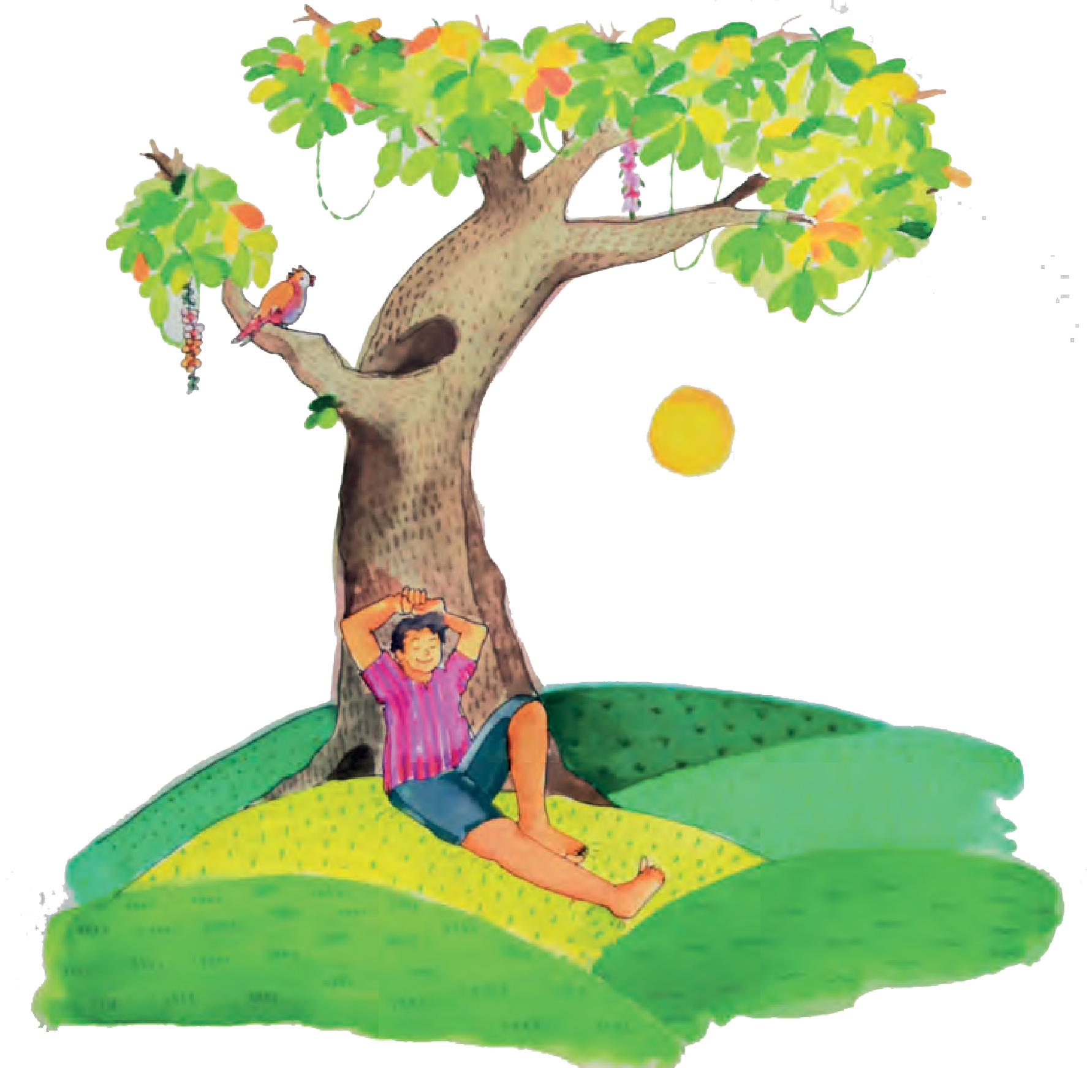

## Under the Greenwood Tree

4

Under the greenwood tree Who loves to lie with me, And turn his merry note Unto the sweet bird’s throat,

Come hither, come hither, come hither ! Here shall he see

No enemy

But winter and rough weather.

Who doth ambition shun,

And loves to live i’the sun, Seeking the food he eats,

And pleased with what he gets, Come hither, come hither, come hither:

Here shall he see No enemy

But winter and rough weather.

*- William Shakespeare*

* * *

79

**ENGLISH WORKSHOP**



1. From the poem, find the old word used for each of the following :
   * towards • here • does
2. **Write in your own words**.
3. Who does the poet invite to join him ?
4. How should that person sing ?
5. What message does the poem convey ?
6. Pick out the lines that mean :
7. Sing in such a manner :
8. One who wishes to join me :
9. Who gives up his desire for wealth, power, fame, etc. :
10. Life in the forest is free from ill-wishers :
11. Happy to eat whatever he can get :
12. Find from the Internet and write down.
13. In which century did William Shakespeare write his famous plays ?
14. From which play is this song extracted ?
15. Which character from the play sings this song ?
16. **Be a poet**. Try to complete the following poem with words that rhyme with each other.

I’d love to live a life that’s Relax under a shady t

And fall into a dreamy s With no strict hours, forced to k

And sing aloud a merry Untrodden paths, as I walk a

You ask me what I’d get to Fruits and nuts and berries sw

You ask me with whom I’d get to p Birds and animals, happy and g

And if a woodcutter put a c Firmly, I would put a st

So that’s the life I’d like l Free from worries, free from gr

,

,

p,

,

g.

?

p

d

d

80

## Unke Munke Timpetoo



 Find the sentences

in which the author and his friend claim that they do not

believe in magic ?

 What do their actions show ?

The teacher should discuss the issue of blind belief in charms and chants with the students, and encourage a rational attitude

to help them understand the story better.

81

“It will be a fantastic birthday this year,” I said in a mocking tone. “All I will get is a pair of shoes and a hand-knitted pullover. I had asked for a table tennis set, but my mother said, ‘It is totally out of the question this year’.”

My friend, Muk looked at me thoughtfully. He drew a bit closer and said, “Well, Rohan, I don’t say I believe in it, but my cousin said it works. And there is no harm trying, don’t you think?”

“Trying what?” I asked.

“Well, my cousin said, ‘If you really want something badly, all you have to do is to run around a banyan tree at midnight and chant seventeen times: Unke, Munke, Timpetoo’. ”

I desperately wanted my wish to come true. Still I asked, “Why seventeen times and why at midnight ?”

“Don’t ask me,” replied Muk, who was my best friend. “That is how it is done, I suppose. Why not try it ? It would not do any harm.”

I thought it was all nonsense. Besides, I couldn’t think of any banyan tree in our neighbourhood. There was one in old Mrs Groover’s garden. But who dared to enter her garden ? Not me ! And not at midnight ! Mrs Groover had been the principal of our school till last year. One look from her piercing pale green eyes was enough to silence bullies like Rinkoo Lal of Class X. I had seen it happen with my own eyes.

“Forget it,” I said. However, the thought kept haunting me till the day before my birthday and I just could not think of anything else.

“Okay,” I said to Muk, “if you come along with me, I will go to Mrs Groover’s garden tonight and do it.”

 Note the description of the scene which creates an atmosphere of mystery.

Read it aloud in a suitable manner.

 If you hear about something that fulfils your wishes, would you try it ?

 Do you think the author is brave ?

“Why should I come along?” asked Muk, “I have no secret wish.”

“Come on, let us go and wish for my table tennis set.” So, at ten minutes to twelve Muk and I met at the back of old Mrs Groover’s garden. We climbed and sat on the boundary wall. We looked down into the garden, which lay dark and silent in the dim light of the moon. And there was a banyan tree, its aerial roots swaying in the gentle breeze of the night. We jumped down, reached the tree and looked around carefully.

“Imagine, if she is awake!” I whispered and pointed at Mrs Groover’s house.

“Nobody is awake at this ghostly hour of the night,” hissed Muk. “Now get going. Run!”

I ran. I ran as fast as I could, chanting “Unke, Munke, Timpetoo, I wish my wish is coming true !” over and over again. I felt a bit scared. That was why I tried to get it over quickly and increased my speed. I increased the chanting too ! And all the while I went on listening to the sounds of the night, a crackle here, a swish there.

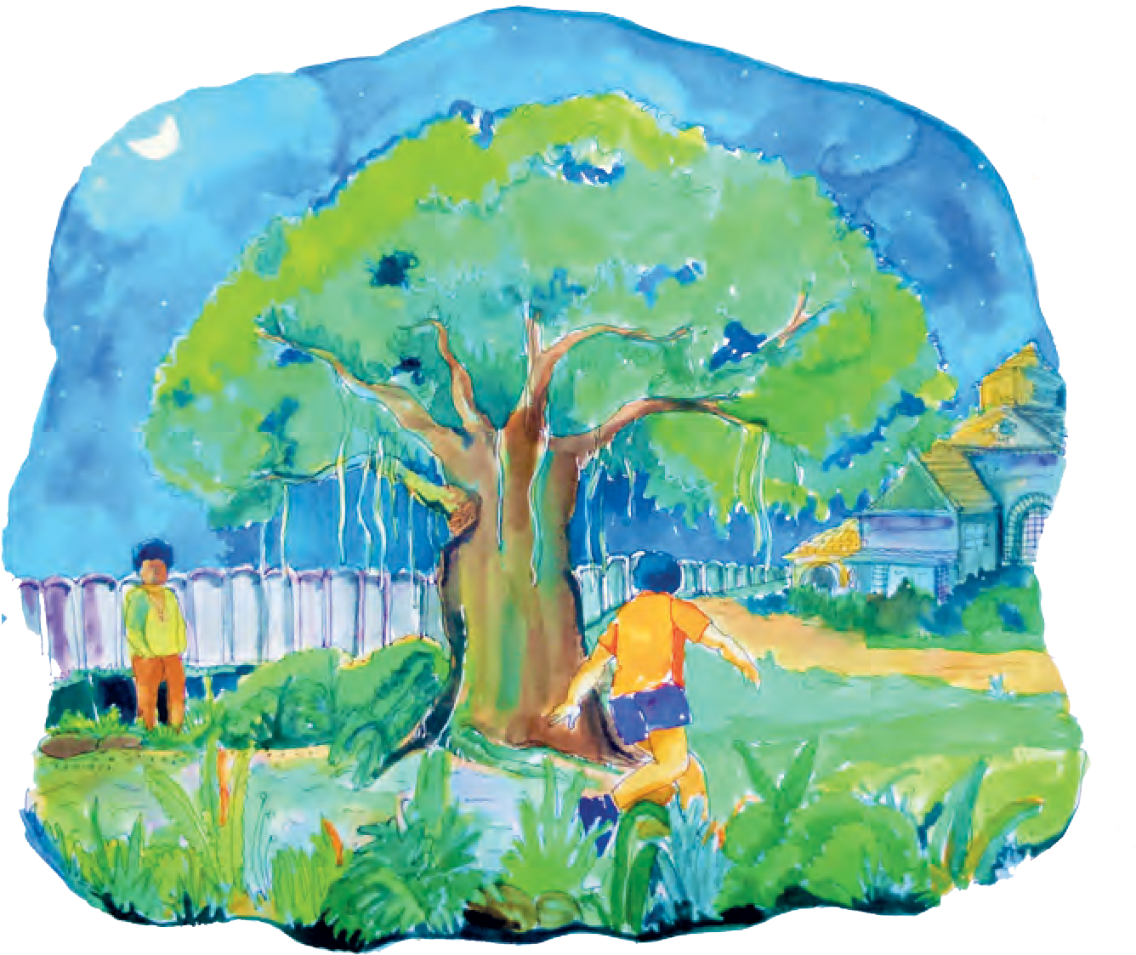

82

Suddenly a ferocious bark tore the stillness of the night ! I froze. Inside Mrs Groover’s house, lights flashed on and the backdoor was pushed open.



 How do we know

that Muk was frightened ?

 What opinion

do you form of Mrs Groover from the way she treats the boys ? Discuss.

 Did the author

really rejoice over his shoes and pullover ?

83

“Who is there ?” called Mrs Groover. “Answer, or I will send the dog at you.”

“Muk, Muk,” I mumbled, “Say something.” But Muk was climbing up the tree. When I saw Mrs Groover bend down to unleash the dog, I pleaded, “Please don’t send the dog at us. I will explain everything, if you let me.”

“Speak out soon,” Mrs Groover shouted.

I told her everything. I feared, she might not believe me. But she listened to me without interruption. She just looked at me with the hard, light green eyes of hers as if she was trying to see right into my heart.

“So ?” she asked finally, “and you believe in Unke, Munke, Timpetoo? Do you think it will help ?” I dropped my head and said softly, “I hope it will!”

“Well,” she returned, “if you believe so, go and finish your rounds.” She turned saying, “and while leaving, would you mind using the front gate ?”

I did finish the remaining six rounds and left her garden using the front gate. I swore that I would never return.

And then the great moment came. I opened my gifts, rejoiced over my new pair of shoes and the hand-knitted pullover ! And then my eyes fell on a parcel. A big parcel !

I had never received such a big parcel earlier. “To Rohan Khanna,” I read, “From Unke,

Munke, Timpetoo !”

I stared at Muk, and he looked as surprised as I was. My mother asked, “Who is Unke, Munke,

Timpetoo ? Isn’t that an unusual name ?” “Yes,” I said, “very unusual indeed.”



 The table tennis

set was not new, but was a

fabulous set, what does it imply ?

 Did the surprise

gift really come from Unke, Munke, Timpetoo ?

 In your opinion, who must have sent the gift ?

**Discuss.**

 What is ‘Unke, Munke,

Timpetoo’ - a charm or an act of friendliness ?

84

I bent over the parcel and began to unpack it. I removed the strings and the paper impatiently. Finally I removed the colourful gift wrapping and found a table tennis set! It was not a brand new table tennis set, but it was a fabulous one. “Wow,” I whispered, just “Wow!”

Till today Muk swears he has nothing to do with it. And so do my parents. I wondered if old Mrs Groover was responsible for the surprise. I wondered for a very long time. One day I gathered up all the courage I possessed and went to meet Mrs Groover. I used the front gate and rang the bell. I had gone over my lines a hundred times, but when she looked down on me with her pale green eyes, I felt my heart sink, and my courage vanish and all I could do was stutter like an idiot. “Good afternoon, Madam, do you, I mean did

you, have you ... sorry, but ... do you believe in

... Unke, Munke, Timpetoo ?”

Mrs Groover continued to look at me with a strange look in her eyes. She replied softly but seriously, “Yes, I do believe in Unke, Munke, Timpetoo. I had wished to have somebody over for tea today. And here you are! Now isn’t it a perfect example of Unke, Munke, Timpetoo ?”

She smiled, and she looked so different, almost human !

From that day onwards Muk and I went to see old Mrs Groover quite often. Not only because she made the best tea and had the best cookies. No! we went because we liked her. And then we had one thing in common. We all believed in Unke, Munke, Timpetoo !

*- by Sigrun Srivastava from ‘Some More Short Stories’*

* * *

**ENGLISH WORKSHOP**



1. Make adjectives from the following.
   * harm • continu(e) • believe
   * fear • thought • wish
   * question • courage
2. Choose the correct alternative.
3. Rohan desperately wished for .

(i) a pair of shoes (ii) a warm pullover

* 1. a good friend (iv) a table-tennis set

1. Rohan and Muk entered the garden at mignight .

(i) to frighten Mrs Groover (ii) to chant arount the banyan tree

* 1. to steal some fruits (iv) to look for a table-tennis set

1. Rohan had finished rounds of the tree before Mrs Groover discovered him.

(i) seventeen (ii) six (iii) eleven (iv) twelve

1. The table-tennis set was gifted by .

(i) Mrs Groover (ii) Rohan’s parents (iii) Muk (iv) Timpetoo

1. The Principal turned out to be a very lady.

(i) poor and simple (ii) proud and rich

* 1. kind and understanding (iv) sad and lonely

1. The story has a very heart-warming and touching end. Now try to **change the end of the story** to make it sound (i) very funny (ii) full of horror and mystery.
2. ‘Unke, Munke, Timpetoo,

I wish, my wish is coming true.’

Try to **compose** two other funny magical chants that have rhyming lines.

1. Language study : **Prefix and suffix :** A letter or group of letters added to the front of a word to change its meaning and make a new word is called a **prefix**. Examples : • un + tie  untie • non + stop  non-stop
   * dis + like  dislike • super + man  superman
   * inter + national  international

* Find at least 5 words with prefixes and identify the prefix in each word.

A letter or group of letters added at the end of a word to make another word is called a **suffix**. Examples : • teach + er  teacher

* + act + or  actor • child + hood  childhood • friend + ship  friendship
  + king + dom  kingdom • use + ful  useful • frequent + ly  frequently
  + act + ion  action • star + ry  starry
* Find 5 examples of words with the following suffixes from the lessons you have studied so far, or from other sources :
  + -ship • -less • -ness • -ly • -ful • -able

85

Like other Sherlock Holmes stories, this story, too, is told by his friend,

Dr Watson.

* League : an association or a formal group of people

## The Red-Headed League

#### Part I : Mr Wilson’s Story

**Things to do :**



 Find samples of ‘classified ads’ from an English newspaper. Where will the advertisement given here be seen in the classifieds ?

 What do you have to do when you are told to ‘apply in person’ ?

 Find out how photographs were developed in those days.

* + - pawn - broker : a person who lends money at interest when valuable things are kept with him till the loan is repaid.

86

86

The advertisement had appeared in newspaper two months ago. Mr Wilson’s assistant, Vincent Spaulding, had shown it to him. Mr Wilson liked his assistant Spaulding. He was smart, efficient and worked for only half the normal wages ! But, the assistant also had his faults. Every now and then, he left work and went down into the cellar to develop photographs. Photography was his hobby.

TO THE RED-HEADED LEAGUE

There is a vacancy for a member of the League, and the salary is four pounds a week for nominal services. Red-headed men may apply in person on Monday, at eleven o’clock, to Duncan Ross, at the office of the League, 7 Fleet Street.

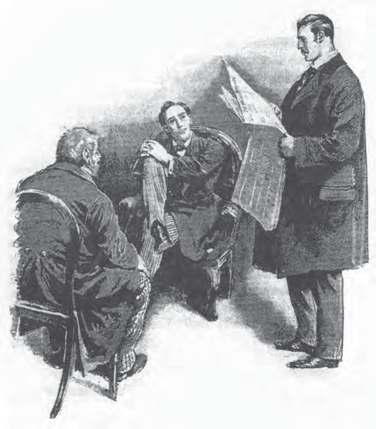

Spaulding showed the advertisement to Mr Wilson and explained to him that an American millionaire, Mr Ezekiah Hopkins, had founded the famous Red-headed League, to help all red-heads like himself. Spaulding urged Mr Wilson to apply for the job. So, the two of them went to the address given in the advertisement.



**Think and answer :**

 Who do you think is smarter -

Mr Wilson or his assistant ?

 Give reasons for your answer.

**Listen and answer :**

 Why was Fleet Street full of red-headed

people ?

 Who was well suited

for the job ?

 Why did Mr Wilson

accept the job ?

 Would you like to do such a job ? Why ?

 Why would

anyone want to copy an encyclopedia ? Think of two good reasons.

 What would we do today, if we needed copies of text from a big book ?

87

Fleet Street was full of red-headed people. Mr Wilson thought that with so much competition he would not get the job. He wanted to go back, but Spaulding pushed through the crowd and took Mr Wilson to the office.

There was nothing in the office but a couple of chairs and a table. A red-headed man sat behind the table. He was Mr Duncan Ross, a representative of the Red-headed League. He was very pleased to see Mr Wilson, and announced immediately that he was well suited for the job. He shook hands with Mr Wilson, congratulated him, and told all other candidates to go back.

Mr Duncan Ross explained that Mr Wilson would have to be in the office from ten to two. If he left the office, he would lose the job. Spaulding assured Mr Wilson that he would look after Mr Wilson’s business in his absence. The pay was fixed at four pounds a week.

“And the work?” said Mr Wilson.

“You have to copy out the Encyclopedia Britannica.”

The pay was very good, and the work was light. Mr Wilson accepted the job and began his work the very next day. Mr Duncan Ross was there in the office to see that Mr Wilson did his work properly and did not leave the office. He told Mr Wilson to start with the letter ‘A’. Mr Wilson wrote diligently for four hours without leaving his place. Mr Ross would drop in from time to time to see that all was right with Mr Wilson. At two o’clock, he bade Mr Wilson good-day, and locked the door of the office.

87

“This went on day after day, Mr Holmes,” said Mr Wilson, “and on Saturday I got my salary. It was the same next week, and the same the week after. After a few days, Mr Duncan Ross came in only once in a while and after a time, he did not come in at all”.



* dissolved : disbanded. Here, it means the organisation has come to an end.

**Things to do :**

 What is the difference between a dictionary and an encyclopedia? Find out.

 Suggest a few words that may appear under ‘A’ after Archery in an encyclopedia.

**Discuss :**

 What would you advise Mr Wilson to do in

the given situation ?

88

Mr Wilson continued, “Eight weeks had passed like this, and I had written about Abbots, Archery etc. and hoped that I might get on to ‘B’ soon. And then suddenly the whole business came to an end.”

“To an end?” Holmes asked.

“Yes, Sir. This morning, I went to my work as usual at ten o’clock, but the door was shut and locked with a little note nailed on it. It said –

**The Red-headed League is dissolved.**

**Oct 9, 1880.**

I was shocked. I did not know what to do”.

Mr Wilson went on with his story, “I made enquiries at the nearby offices, but none of them knew anything about the League. The rooms had been rented under a false name.

“I went home and asked my assistant Spaulding for advice. But he could not help me in any way. I want to find out about the League, Mr Holmes, who they are and why they played this prank upon me. The whole thing is a mystery. That is why I came to you. I have heard a lot about you”.

Holmes found Mr Wilson’s story very unusual. He asked, “Mr Wilson, this assistant of yours who first called your attention to the advertisement – what is he like?”

“Small, stout, with no hair on his face. He has a white splash of acid on his forehead.”

“I thought as much,” said Mr Holmes. “Is he still with you?”

“Oh, yes, sir.”

“That will do, Mr Wilson. I can give you my opinion on this subject in a day or two. Today is Saturday, and by Monday we may come to a conclusion.”

88



**ENGLISH WORKSHOP**

1. Find and write the descriptions of different people given in this

story.

1. **Present Mr Wilson’s story as it would be shown in a comic strip**. Write what picture you will show in each frame along with the dialogues. Write the dialogue with the help of the story. Examples :

Spaulding to Wilson : Will you take me as your assistant ? I’ll work for half the wages.

Mr Wilson’s shop

Spaulding : Sir, there’s no work here. I’ll go down to the cellar to develop my photos.

Mr Wilson’s shop

Spaulding to Wilson : Sir, look at this ad. It is for red-headed people.

Mr Wilson’s shop

**Frame 1 Frame 2 Frame 3**

1. Form groups of five. Discuss how you can complete the rest of the story without referring to Part II of the story.
2. Language Study : **Modal auxiliary :** You have read about **main verbs** and **auxiliary verbs** in Std VI. You know that auxiliary verbs are helping verbs. **Modal auxiliary** verbs or **modal verbs** are also helping verbs. They are used with main verbs to show changes / modifications in the meaning of the main verb. They show possibility, ability, permission, intention, etc.

The modal auxiliaries are :

* + can, may, shall, will
  + could, might, should, would
  + must, ought to, used to, need, dare ...

Remember the following :

* We do not use ‘to’ before a modal.
* We do not add ‘-ed’ or ‘-ing’ to a modal.
* We can form questions and negative sentences using modals without using the auxiliaries be, have, or do.

Examples :

* + They can swim.  May I come in ?  We shall sing.
  + Can he swim?  You may go.  She ought to play.
  + He cannot swim.  You must go.  They might come.
* Frame simple sentences -statements, questions, requests, orders, permissions, etc. using the modals listed above.

  

89

#### Part II : What happened next -



**Listen and answer :**

 Tell the name of the young man who opened the door to Mr Holmes.

 What did Holmes want to see ?

 Guess where

Mr Merryweather took the others.

* Strand : a famous place in London.
* cellar : a room used for storage under a building

90

**Dr Watson’s Account**

“Well, Watson, what do you think of it all?” asked Mr Holmes, after Mr Wilson had left.

“I make nothing of it,” I answered frankly. Holmes sat silently for some time, and then invited me to go out with him. We went to the square where Mr Wilson had his shop. Holmes observed the area carefully. There were many shops and offices in the square, and a bank just behind Mr Wilson’s shop. Holmes spent some time outside the shop and thumped upon the pavement two or three times. Finally, he knocked on Mr Wilson’s door. A young man opened the door. Mr Holmes asked him the way to the Strand. The Assistant answered the question, and quickly closed the door.

I said, “I am sure that you enquired your way only in order to see him.”

“Not him,” Holmes said, “but the knees of his trousers.”

“And what did you see?”

“What I expected to see. This matter of Wilson’s is serious. A crime is being planned. But I hope that we can stop it. The offices and banks will be closed for the weekend. Now I’ve to go and make some arrangements, but I shall want your help tonight. Come to Baker Street at 10.00 and bring your revolver.”

I arrived at Holmes’ residence in time. There were two other men with him – Mr Jones of Scotland Yard and Mr Merryweather, a banker. Holmes announced, “Tonight we are going to hunt one of the smartest criminals in London !”

We left together in a carriage and reached the road we had visited in the morning. Holmes told us to follow Mr Merryweather who led us through an

90

iron gate. We followed him down a narrow passage. After going down some stone steps, he led us down a dark, earth-smelling passage and into a huge cellar, full of big boxes. We all sat on the boxes.



* take the criminals by surprise : catch the criminals without giving them a warning

**Think, discuss and guess the answer :**

 How did Mr Merryweather come to know about

the crime ?

 Why did Mr Holmes think the criminals would act that night ?

* stopped all the holes : closed all the routes by which the criminal may escape / run away

91

“We are in the cellar of the City branch of one of the main banks in London. Mr Merryweather is the chairman of the bank, and he will tell you why a criminal should take an interest in this cellar at present,” said Holmes. Mr Merryweather explained that the bank had borrowed a huge quantity of gold from the Bank of France and the boxes in the cellar were full of gold.

Holmes expected the criminals to act that very night. We had to wait there in total darkness without making any noise to take the criminals by surprise.

“They have but one escape route,” whispered Holmes. “That is back through Mr Wilson’s house. I hope that some men are waiting at Mr Wilson’s door, Mr Jones?”

“I have an inspector and two officers waiting at his door.”

“Then we have stopped all the holes. Now we must be silent and wait.”

We waited silently for more than an hour. It was pitch dark in the cellar. Then suddenly, a point of bright light appeared in the floor of the cellar, then a line, and a gash seemed to open, and a hand appeared. A broad stone turned over upon its side, and left a square hole. A boyish face emerged. The man looked about and came out of the hole. He had a companion with him, a man with very red hair.The pair was none other than Spaulding the assistant alias the criminal Clay and the red-headed Mr Duncan Ross ! As soon as they climbed out of the hole, Sherlock Holmes sprang out and seized Clay by the collar.

91



* foiled : laid waste, prevented
* object : purpose, reason

**Listen and answer :**

 How did the criminals enter the cellar ?

 Who were the two criminals ?

 Who tried to get away ? Do you think he was able to escape ? Why ?

**Things to do :**

 Explain the trick of the ‘Red-headed League’. How was it related to

Mr Wilson’s hair ?

92

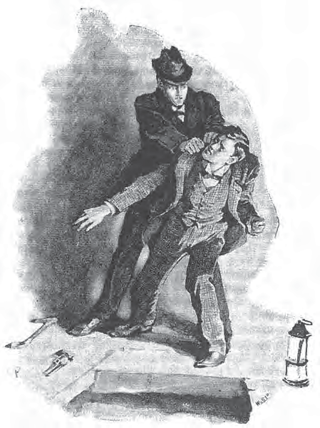

The other dived down the hole and disappeared. Clay took out a revolver. But Holmes hit him on his wrist, and the revolver fell on the floor.

“It’s no use, John Clay,” said Holmes, “we have caught you.”

“So I see. But my friend has escaped.”

Holmes replied, “He cannot escape. There are three men waiting for him at the other end !”

Then Holmes handed over Mr Clay to the policemen.

Mr Merryweather said, “Really, Mr Holmes, I do not know how to thank you. You have foiled one of the most cunning attempts at bank robbery. The bank is grateful to you.”

92

“You see, Watson,” Holmes said, after we reached his home, “it was obvious from the first that the only possible object of the strange advertisement and the peculiar job was to get Mr Wilson away from his shop for some hours every day. The Red-headed League was a clever idea. In Mr Wilson’s absence, Clay and his red- headed companion wanted to dig an underground tunnel from Mr Wilson’s house to the bank. Then, they would be able to enter the bank and steal the gold without breaking open the doors of the bank. Using the tunnel, they entered the cellar. They planned to steal the gold, and go back to Mr Wilson’s house, again through the tunnel, and then get away.



**Listen and answer :**

 Why did Holmes become suspicious ?

 How did Holmes find out that the assistant was a

criminal ?

 How did Holmes guess that he was digging a tunnel ?

93

“But how could you guess what their motive was?”

“When I heard that the assistant worked for half the wages, I became suspicious. Using Mr Wilson’s description of his assistant, I made enquiries. I found that he was the criminal Clay. Why was he working in Mr Wilson’s shop ? And his habit of going into the cellar every now and then ! I inferred that he must be digging a tunnel to some other building. When we visited the shop, I beat upon the pavement with my stick to find out whether the cellar stretched out in front or behind. It was not in front. I saw the bank on the other side of the house and guessed what the criminals had in mind. When Clay answered the bell, the knees of his trousers were wrinkled and stained! It confirmed my suspicion that he was digging. You know the rest of the story.

I am so quick and noiseless !

“You reasoned it out beautifully!” I exclaimed in admiration.

*- Adapted from ‘The Red-headed League’*

*by Sir Arthur Conan Doyle*

* * *



**ENGLISH WORKSHOP**

1. **Put the following events in proper order**.
   * Holmes and others go to the bank.
   * Clay digs a tunnel.
   * Ross closes the office of the ‘Red-headed League’.
   * Holmes catches the criminal Clay.
   * Clay and Ross enter the cellar to steal the gold.
   * The bank received a lot of gold from the Bank of France.
   * Holmes visits the area around Mr Wilson’s shop.
2. From the passage, find adverbs that end with ‘-ly’. Find the adjective in each of the adverb.
3. Discuss the following elements of a detective or mystery story.
   * a mystery • strange happenings • a smart detective who investigates the happenings • a crime / possibility of a crime • preventing the crime and catching the criminal. • characteristics of the victim • characteristics of the criminal • characteristics of the detective

Use the elements to **prepare outlines** of detective stories using your imagination. Write a story using any one of the outlines.

1. Use the following outline to develop a story as a group activity. Then write the story individually.

Family returns home late at night  hear converstation between thieves from inside the locked house  family gets ready to counter  attack  father opens the door  all enter  no one is seen  but TV is on  detective serial midway.

1. Language Study : **Synonyms, antonyms, homonyms : Synonyms** are the words from the same language that have the same or more or less the same meaning.

Examples : • good – nice – pretty • shut – closed – sealed

* + intelligent – bright

**Antonyms** are words from the same language that have opposite meanings. Examples : • strong – weak • right – wrong • hard – soft • up – down

**Homonyms** are words that are spelt and pronounced in the same way but have different meaning.

Examples : • round (adjective) – round (noun) • walk (noun) – walk (verb)

* Start a collection of synonyms, antonyms and homonyms. Collect at least 50 each. Keep adding to your selection.

  

94

## Home Sweet Home

’Mid pleasures and palaces though we may roam, Be it ever so humble, there’s no place like home; A charm from the sky seems to hallow us there,

Which, seek through the world, is ne’er met with elsewhere.

Home, home, sweet, sweet home !

There’s no place like home, oh, there’s no place like home !

An exile from home, splendour dazzles in vain; Oh, give me my lowly thatched cottage again ! The birds singing gayly, that come at my call -

Give me them - and the peace of mind, dearer than all !

Home, home, sweet, sweet home !

There’s no place like home, oh, there’s no place like home !

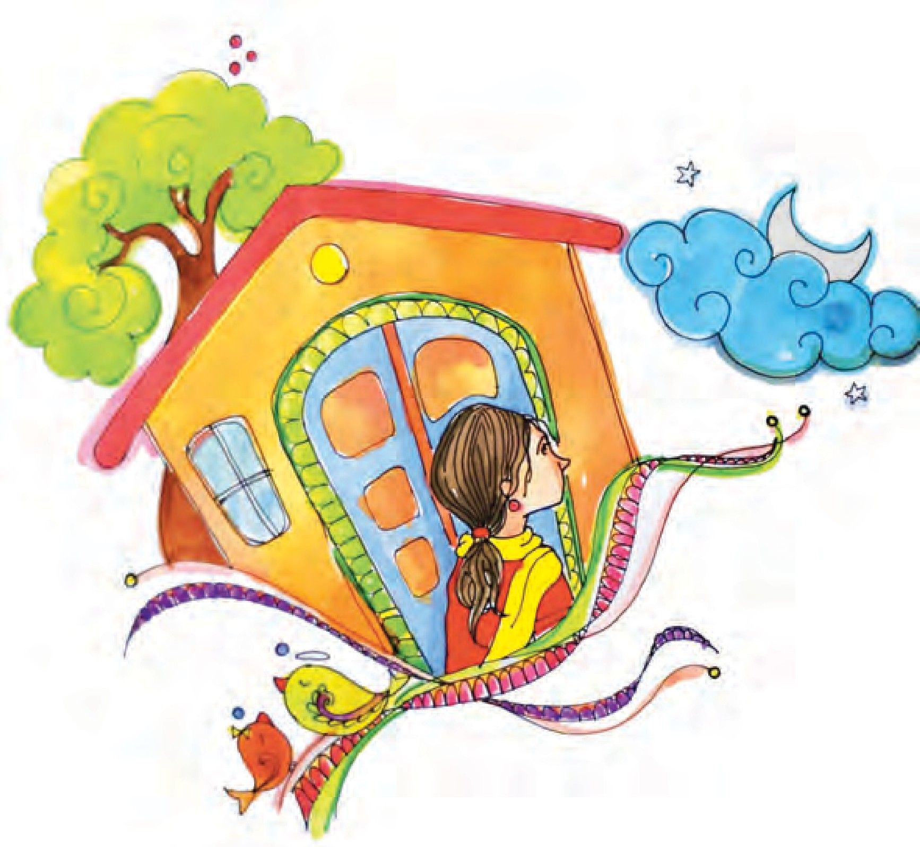

I gaze on the moon as I tread the drear wild, And feel that my mother now thinks of her child,

As she looks on that moon from our own cottage door Thro’ the woodbine, whose fragrance shall cheer me no more.

Home, home, sweet, sweet home !

There’s no place like home, oh, there’s no place like home !

95

How sweet ’tis to sit ’neath a fond father’s smile, And the caress of a mother to soothe and beguile !

Let others delight mid new pleasures to roam, But give me, oh, give me, the pleasures of home.

Home, home, sweet, sweet home !

There’s no place like home, oh, there’s no place like home!

To thee I’ll return, overburdened with care; The heart’s dearest solace will smile on me there;

No more from that cottage again will I roam; Be it ever so humble, there’s no place like home.

Home, home, sweet, sweet, home !

There’s no place like home, oh, there’s no place like home !

- *John Howard Payne*



**ENGLISH WORKSHOP**

1. Write in your own words.
   1. How does the poet glorify his home in the first stanza ?
   2. How does the poet describe his home in the second stanza ?
   3. What makes the poet remember his mother ?
   4. What does the poet miss ?
   5. What does the poet hope for ?
   6. In which professions is a person forced to stay away from his home/ homeland for a long time ? Try to guess why the poet is forced to stay away from his home ?
2. Write out a few things that you would really miss about your home if you were to stay away from it for long.

  

96

## Seeing Eyes Helping Hands



Home for the Aged, East Street, Girgaon - 4

10 January 2018

To

The Principal,

New Vision High School, Off Main Street, Girgaon - 1

Dear Ms Ambekar,

It was the first time that school children had come to help at our Home for the Aged on 5th January, and I am glad to inform you that their visit was a great success.

The children carried out all the tasks we had planned for them. They did them willingly and obediently. And, of course, our residents enjoyed the story-telling sessions quite as much as the students did.

In fact, we were wondering whether we could have a few of your students visiting us every month. You can imagine how much our residents enjoyed having young visitiors. It brightened up the whole week for them. And I must admit that the ‘Helping Hands’ really lightened some of our work.

With warm regards,

Yours sincerely,

Secretary Home for the Aged

**A : A letter of thanks**

97

(*In the Principal’s Office*)

**Principal :** Yes, Mr Bendre. You wanted to see me about something ?

**Mr Bendre :** Yes, Madam. I’ve come to say how much we appreciate the good work that the school is doing under S. E. H. H.

**Principal :** Oh, thank you. Our teachers were keen on the programme because they were sure that it would help the children.

**Mr Bendre :** And I can tell you that it has really made a difference. My son and his cousin both study in this school. I have been following their activities throughout the year. I’m really impressed with the changes in their thinking and even their behaviour.

**Principal :** I’m glad you feel that way.

**Mr Bendre :** I think the parents will all thank you for paying attention to this aspect of personality development. I want to congratulate you specially at the next Parent Teacher Association meeting.

**Principal :** Thank you so much.

**B : Giving thanks personally**

1. Study the following format of an **informal letter** carefully. Using the format,

(a) Write an informal letter to your friend who has gone to another town for a month. (b) Write a personal letter of thank to an elder person.

Place Date

My dear /Dear

,

With warm regards,

Yours,

P. S.

Main body / text of the letter

Sender’s name, as known to the receiver

Post script : (Extra matter added after writing the letter. This part is optional.)

1. Form a group of four to six. As a group activity, write a conversation in which a person / a group of persons thanks someone.

98

## Papa Panov’s Special Christmas

It was Christmas Eve and although it was still

afternoon, lights had begun to appear in the shops and houses of the little Russian village, for the short winter day was nearly over. Excited children scurried indoors and now only muffled sounds of chatter and laughter escaped from closed shutters.

Old Papa Panov, the village shoemaker, stepped outside his shop to take one last look around. The sounds of happiness, the bright lights and the faint but delicious smells of Christmas cooking reminded him of past Christmas times when his wife had still been alive and his own children little. Now they had gone.

His usually cheerful face, with the little laughter wrinkles behind the round steel

spectacles, looked sad now. But he went back indoors with a firm step, put up the shutters and set a pot of coffee to heat on the charcoal stove. Then, with a sigh, he settled in his big armchair.

Papa Panov did not often read, but tonight he pulled down the big old family Bible and, slowly tracing the lines with one forefinger, he read

again the Christmas story. He read how Mary and Joseph, tired by their journey to Bethlehem, found no room for them at the inn, so that Mary’s little baby was born in the cowshed.

“Oh, dear, oh, dear!” exclaimed Papa Panov, “if only they had come here ! I would have given them my bed and I could have covered the baby with my patchwork quilt to keep him warm.”

He read on about the wise men who had come to see the baby Jesus, bringing him splendid gifts.

 In the little village, what shows that it is Christmas time ?

**Think and answer :**

 Did Papa Panov have a shop away from his home ?

 Did he live alone ? Why ?

 What do the

‘laughter wrinkles’ tell us ?

 What tells us that Papa Panov is a kind person ?

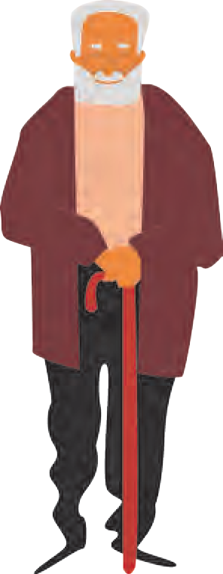

99

Papa Panov’s face fell. “I have no gift that I could give him,” he thought sadly.



 Why is the small

box dusty ?

 What thoughts

did Papa Panov have before he fell asleep ?

 Were they related to his dream ?

 Did Papa Panov believe in his dream ?

 In what forms

did Papa Panov imagine Jesus to visit him ?

100

Then his face brightened. He put down the Bible, got up and stretched his long arms to the shelf high up in his little room. He took down a small, dusty box and opened it. Inside was a perfect pair of tiny leather shoes.

Papa Panov smiled with satisfaction. Yes, they were as good as he had remembered - the best shoes he had ever made. “I should give him those,” he decided, as he gently put them away and sat down again.

He was feeling tired now, and the further he read the sleepier he became. The print began to dance before his eyes so that he closed them, just for a minute. In no time at all Papa Panov was fast asleep.

And as he slept he dreamed. He dreamed that someone was in his room and he knew at once, as one does in dreams, who the person was. It was Jesus.

“You have been wishing that you could see me, Papa Panov.” He said kindly, “Then look for me tomorrow. It will be Christmas Day and I will visit you. But look carefully, for I shall not tell you who I am.”

When at last Papa Panov awoke, the bells were ringing out and a thin light was filtering through the shutters. “Bless my soul !” said Papa Panov. “It’s Christmas Day !”

He stood up and stretched himself for he was rather stiff. Then his face filled with happiness as he remembered his dream. This would be a very special Christmas after all, for Jesus was coming to visit him. How would he look ? Would he be a little baby, as at that first Christmas ? Would he be a grown man, a carpenter - or the great King

that he is, God’s Son ? He must watch carefully the whole day through so that he recognised him however he came.

Papa Panov put on a special pot of coffee for his Christmas breakfast, took down the shutters and looked out of the window. The street was deserted, no one was stirring yet. No one except the road sweeper. He looked as miserable and dirty as ever, and well he might! Whoever wanted to work on Christmas Day - and in the raw cold and bitter freezing mist of such a morning ?

Papa Panov opened the shop door, letting in a thin stream of cold air. “Come in !” he shouted across the street cheerily. “Come in and have some hot coffee to keep out the cold !”

The sweeper looked up, scarcely able to believe his ears. He was only too glad to put down his broom and come into the warm room. His old clothes steamed gently in the heat of the stove and he clasped both red hands round the comforting warm mug as he drank.

Papa Panov watched him with satisfaction, but every now and then his eyes strayed to the window. It would never do to miss his special visitor.

“Expecting someone ?” the sweeper asked at last. So Papa Panov told him about his dream.

“Well, I hope he comes,” the sweeper said, “you’ve given me a bit of Christmas cheer I never expected to have. I’d say you deserve to have your dream come true.” And he actually smiled.

When he had gone, Papa Panov put on cabbage soup for his dinner, then went to the door

again, scanning the street. He saw no one. But he was mistaken. Someone was coming.

 Have you ever noticed how some people have to work even on festivals ? Who are they ?

 Why did Papa Panov give hot coffee to the sweeper ?

 Why did he tell the sweeper about

his dream ?

 Why did the sweeper smile ?

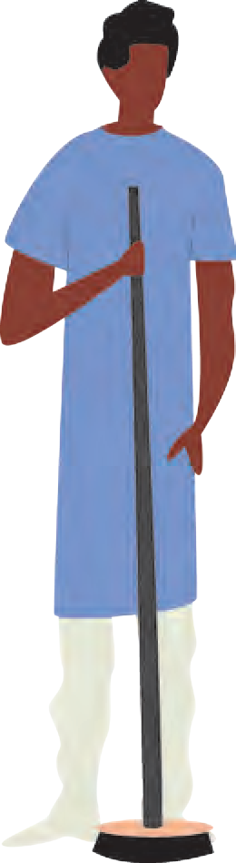

101



 What does the way the girl walked suggest ?

**Guess the meaning of the following.**

* “You both need a warm by the fire and a rest”.
* The young mother let him shepherd her indoors.

 Why did Papa Panov give the shoes to the baby though he had been keeping them for Jesus ?

102

The girl walked so slowly and quietly, hugging the walls of shops and houses, that it was a while before he noticed her. She looked very tired and she was carrying something. As she drew nearer he could see that it was a baby, wrapped in a thin shawl. There was such sadness in her face and in the pinched little face of the baby, that Papa Panov’s heart went out to them.

“Won’t you come in,” he called, stepping outside to meet them. “You both

need a warm by the fire and a rest.”

The young mother let him shepherd her indoors and to the comfort of the armchair. She gave a big sigh of relief.

“I’ll warm some milk for the baby,” Papa Panov said, “I’ve had children of my own - I can feed her for you.” He took the milk from the stove and carefully fed the baby from a spoon, warming her tiny feet by the stove at the same time.

“She needs shoes,” the cobbler said.

But the girl replied, “I can’t afford shoes, I’ve got no husband to bring home money. I’m on my way to the next village to get work.”

A sudden thought flashed through Papa Panov’s mind. He remembered the little shoes he

had looked at last night. But he had been keeping those for Jesus. He looked again

at the cold little feet and made up his mind.

“Try these on her,” he said, handing the baby and the shoes to the mother. The beautiful little shoes were a perfect fit. The girl smiled happily and the baby gurgled with pleasure.

“You have been so kind to us,” the girl said, when she got up with her baby to go. “May all your Christmas wishes come true !”

But Papa Panov was beginning to wonder if his very special Christmas wish would come true. Perhaps he had missed his visitor ? He looked

anxiously up and down the street. There were plenty of people about but they were all faces that he recognised. There were neighbours going to call on their families. They nodded and smiled and wished him Happy Christmas ! Or beggars - and Papa Panov hurried indoors to fetch them hot soup and a generous hunk of bread, hurrying out again in case he missed the ‘Important Stranger’.



 How does the

author show that Papa Panov was disappointed ?

What actions of Papa Panov suggest it ?

 How does the author describe Papa Panov’s happiness ?

103

All too soon the winter dusk fell. When Papa Panov next went to the door and strained his eyes, he could no longer make out the passers - by. Most were home and indoors by now anyway. He walked slowly back into his room at last, put up the shutters, and sat down wearily in his armchair. So it had been just a dream after all. Jesus had not come. Then all at once he knew that he was no longer alone in the room.

This was not a dream for he was wide awake. At first he seemed to see before his eyes the long stream of people who had come to him that day. He saw again the old road sweeper, the young mother and her baby and the beggars he had fed. As they passed, each whispered, “Didn’t you see me, Papa Panov ?”

“Who are you ?” he called out, bewildered.

Then another voice answered him. It was the voice from his dream - the voice of Jesus.

“I was hungry and you fed me,” he said. “I was naked and you clothed me. I was cold and you warmed me. I came to you today in everyone of those you helped and welcomed.”

Then all was quiet and still. Only the sound of the big clock ticking could be heard.

A great peace and happiness seemed to fill the room, overflowing Papa Panov’s heart until he wanted to burst out singing and laughing and dancing with joy.

“So he did come after all !” was all that he said. *- Leo Tolstoy*



**ENGLISH WORKSHOP**

1. Write the homophones (words which sound the same) of the following words in the story.
   1. no : (4) went : (7) through :
   2. dear : (5) pair : (8) soul :
   3. here : (6) knew : (9) whole :
2. Correct the following sentences and rewrite them.
   1. The best shoes that Papa Panov had made were a pair of lady’s shoes.
   2. Papa Panov gave hot soup to the sweeper, milk to the young mother and coffee to the beggars.
   3. By afternoon, Papa Panov had stopped looking out for Jesus.
   4. Papa Panov saw the sweeper, the young mother and the beggars he had helped only once in the morning.
   5. Jesus had actually visited Papa Panov only once on Christmas Eve.
3. Write a character sketch of Papa Panov in your own words.
4. **Write your own interpretation** of the story.
5. Do you know of similar stories in your mother tongue or in other languages ? Narrate it in short.
6. Gather more information about cold winters in Russia.
7. Which season would you say is the hardest in your locality ? What help would the poor and homeless people need in that season ?

  

104

*E-learning material for the Standards I to XII*

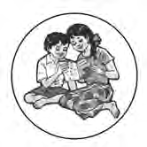

**Available in Marathi and English medium**

**ebalbharati**

**Features**

* Inclusion of prescribed subjects as per subject scheme.
* Complete E- learning material based on textbook
* In the form of audio-visual
* Presentation of chapterwise content and inclusion of questions as per necessity
* Inclusion of various activities, pictures, figures/diagrams, etc.
* Use of animation for easy and simple learning
* Inclusion of exercises.

E-learning material (Audio-Visual) for the Standards One to Twelve is available through Textbook Bureau, Balbharati for the students of Marathi and English medium.

For purchasing E-learning material...

* Register your demand by scanning the Q.R. Code given above.
* Register your demand for E-learning material by using Google play store and downloading ebalbharati app.
* Visit the following websites of the Textbook Bureau. [www.ebalbharati.in](http://www.ebalbharati.in/)

[www.balbharati.in](http://www.balbharati.in/)

